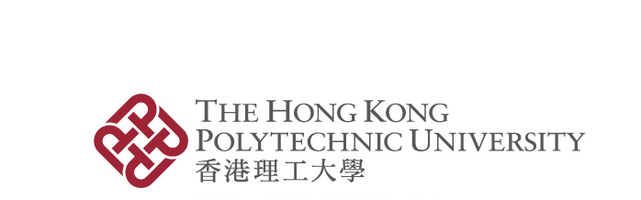
Proposed Changes to Ongoing Projects of Strategic Importance
Form AoEC/4
(Sep 2021)

Notes:
- For information on change requests, please refer to the Information Note on the Projects of Strategic Importance, which is available at the RIO’s website at: https://www.polyu.edu.hk/rio/ (under “Research Grants & Contracts” → “Areas of Excellence Committee” → “Projects of Strategic Importance”).
- For changes in sub-projects, endorsement of the PI/Rep. Co-PI of the main project is required before the consideration of the AoEC.

Section A (To be completed by the PI/Rep. Co-PI)
Project Title: |  |  |  |  | A/C Code:
PI/Rep. Co-PI: |  |  | Ext.: |  | Dept:

Request for the following change(s) (please tick as appropriate):

 | (1) | Extension of Completion Date
Notes:
- If the project concerned is a sub-project, the proposed completion date should be within the completion date of the main project.
- Please also apply to relevant authorities for extension of the approval of research ethics/safety, if applicable.
- The PI/Rep. Co-PI is only allowed to apply once for an extension of project completion date. All first applications for extension of project completion date should be approved with a condition that it is the final extension. The maximum extension will be capped at 12 months.
- The PI/Rep. Co-PI is required to provide an updated progress report of the project (i.e., summary of project objectives achieved and work plan for the proposed extension period).
Expected Completion Date
 | (Original) |  | (Revised)

 | (2) | Change of Project Title
 | (3) | Change of PI/Rep. Co-PI or Project Team Membership
 | (4) | Creation of New Sub-Project(s)
 | (5) | Others (please specify below like withdrawal and termination of project/sub-project, etc.):

Details and justifications for the above request:
[Attach additional sheet(s) if there is not enough space below]

Signature |  | Date
 | PI/Rep. Co-PI
Section B (To be completed by the PI/Rep. Co-PI of the main project)

(Completion of Section B is required if the changes is applicable in sub-projects only.)

I endorse/do not endorse* the changes as requested in Section A.

Comments/ Remarks, if any:

Signature |  | Date
 | PI/Rep. Co-PI

---------------------------------------------------------------------------------------------------------------------

Section C (To be completed by Departmental / School Research Committee)

I endorse/do not endorse* the changes as requested in Section A.

Comments/ Remarks, if any:

Signature |  | Date
 | (Chair, Departmental / School Research Committee)

---------------------------------------------------------------------------------------------------------------------

Section D (To be completed by Faculty Research Committee/School Board)

(Completion of Section D is required only if the DRC/SRC Chair is a member of the project team and the proposed extension is more than 12 months.)

I endorse/do not endorse* the changes as requested in Section A.

Comments/ Remarks, if any:

Signature |  | Date
 | (Chair, Faculty Research Committee/School Board)

* Please delete as appropriate.
Section E (To be completed by the AoEC)

I approve/do not approve* the changes as requested in Section A.

Comments/ Remarks, if any:

Signature |  | Date
 | AoEC Chairman

* Please delete as appropriate.

(For RIO use)

Project/Sub-Project Account Code _____________________

Copy sent to PI/Rep. Co-PI (for changes in sub-projects, also sent to PI/Rep. Co-PI of the main project) after consideration of the AoEC Chairman via email on __________________.

Copy sent to DRC/SRC Chair on ________________.

Copy sent to FRC Chair/School Board Chair on ________________.

Copy sent to FO for re-activation of the project account, if frozen, via email on ________________.

RIS records updated by ________________ on ____________________.

Sep 2021

