Topic: 14 Smart Cities
[SAMPLE]

Airborne Transmission of COVID-19 Virus
in Enclosed Spaces

Junmei Zhao¹, Nancy Sample^{2*}, Jianguo Yin¹, Jim Chan³
¹School of Energy and Environment, Southwest University, Chengdu 210096, China
²Key Laboratory of Indoor Environment, Newname University, Chicago, IL 34512, USA
³Department of Buildings, Newfound University, Kowloon, Hong Kong SAR, China

*Email: sample@newnameu.edu, Phone: +1-210-987 6543

Abstract

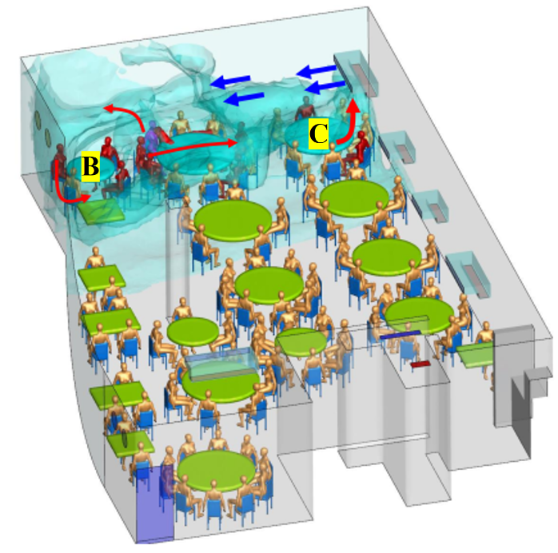
Since the outbreak of COVID-19 in December 2019, the severe acute respiratory syndrome coronavirus 2 (SARS-CoV-2) has spread worldwide. This study investigated SARS-CoV-2 transmissions in several enclosed spaces, such as restaurants such as the one shown in the figure, hospitals, elevators, airplane cabins, buses, etc. by using computational fluid dynamics (CFD). A deterministic and a probabilistic method was used to evaluate the infection risk in those spaces. This study found that the transmission mechanisms of COVID-19 and their main influencing factors, such as airflow patterns, air temperature, relative humidity, and social distancing. The transmission characteristics in existing cases are providing more and more evidence that SARS CoV-2 can be transmitted through the air. The following probabilistic and deterministic research methods: the Wells-Riley equation, the dose-response model, the Monte Carlo model, CFD with the Eulerian method, CFD with the Lagrangian method, and the experimental approach, can be used for studying the airborne transmission mechanism. Our results show that the Wells-Riley equation and dose-response model are great for assessment of the average infection risk. Other methods may provide better accuracy but would often require boundary conditions that were hard to obtain. This study recommends useful tools for studying the airborne transmission mechanism of COVID-19 and epidemic prevention and control in enclosed spaces.
Figure 1. Airflow pattern is important for SARS-CoV-2 transmission in a restaurant (Courtesy of the University of Hong Kong team).

