IFSPA 2022 Paper Submission – Guidelines for Authors

Preparing full papers and/or abstracts for IFSPA conference, authors should follow this guideline. Papers which do not follow these instructions may be excluded from the Conference Proceedings. A template is provided on pages 6-7 for your reference.

File Format
All articles should be submitted in [.doc] or [.docx] file. PDF as the only file type is not accepted, it must be accompanied by the source Microsoft Word file.

Default Style in Microsoft Word
The default style in Microsoft Word should be set as below:
- Font type = Times New Roman
- Font size = 11
- Line spacing = 1.0, with no spacing before or after paragraph
- Paper size = A4
- Margin = Moderate (top & bottom = 2.54 cm; left and right = 1.91 cm)
- Page number should be centered in the footer using Times New Roman, font size = 11

Article Length
Full paper should be a maximum of 7,000 words in length, including references and appendices. Each figure or table will be counted as 280 words.

Article Title
A title with no more than 8 words should be provided in bold using font size = 14.

Author Details
All contributing authors’ names and the corresponding affiliation based at the time the paper was conducted should be listed out under the article title using font size = 11. Affiliation should consist of “Department, Institution, City, State, Postcode, Country” in italics.

Abstract
Limit the abstract text to 250 words and set out under 4-7 sub-headings listed below:
- Purpose (mandatory)
- Design/methodology/approach (mandatory)
- Findings (mandatory)
- Research limitations/implications (if applicable)
- Practical implications (if applicable)
- Social implications (if applicable)
- Originality/value (mandatory)

Footnotes
Do NOT use footnotes unless it is unavoidable. Use Times New Roman, font size = 10 and keep them as short as possible.

Quotations
The sources of all non-original data/information must be quoted in Harvard referencing style. You should cite publications in the text: (Adams, 2006) using the first named author's name or (Adams and Brown, 2006) citing both names of two, or (Adams et al., 2006), when there are three or more authors.

Section and Subsection Headings
The preferred format is for first level headings to be presented in bold and subsequent sub-headings to be presented in medium italics.

Equations and Formulations
All equations in the paper, including those in the appendices, must be numbered consecutively starting from (1). Use the corresponding number e.g. Eq. 1 while mentioning that particular equation in paragraphs. All equations should be left-justified using Times New Roman, font size = 10. For example:

$$\sum_{j}{\left(x_{\text{ij}}+y_{\text{ij}}\right)}≤s_{i}$$ | (1)
$$\sum_{i}{\left(x_{\text{ij}}+y_{\text{ij}}\right)=\sum_{k}{\left(x_{\text{jk}}+y_{\text{jk}}\right)}}$$ | (2)

Figures and Tables
Figures and Tables should be placed as close as to where they are first cited. Centre them between the margins and make sure they do not fall outside of the printing area in the page. Give a suitable title with numbering such as “Figure 1”, “Table 1” and state its source above or below each figure and table. Use Times New Roman, font size = 11 for all numbers and letters. For example:

Table 1: Example of a table
Organizational performance factors | F1 | F2
Turnover growth rate | 0.865 | -0.031
Return on assets | 0.837 | 0.085
Profitability | 0.823 | 0.173
Market share | 0.630 | 0.550
Customer satisfaction | 0.055 | 0.849
Service quality | -0.374 | 0.728
Competitive position | 0.488 | 0.725
Employee productivity | 0.365 | 0.646
Eigenvalues | 3.710 | 1.850
Percentage variance | 46.950 | 23.180
Cumulative variance | 46.950 | 69.630

Source: Author(s) of the original source (publication year)

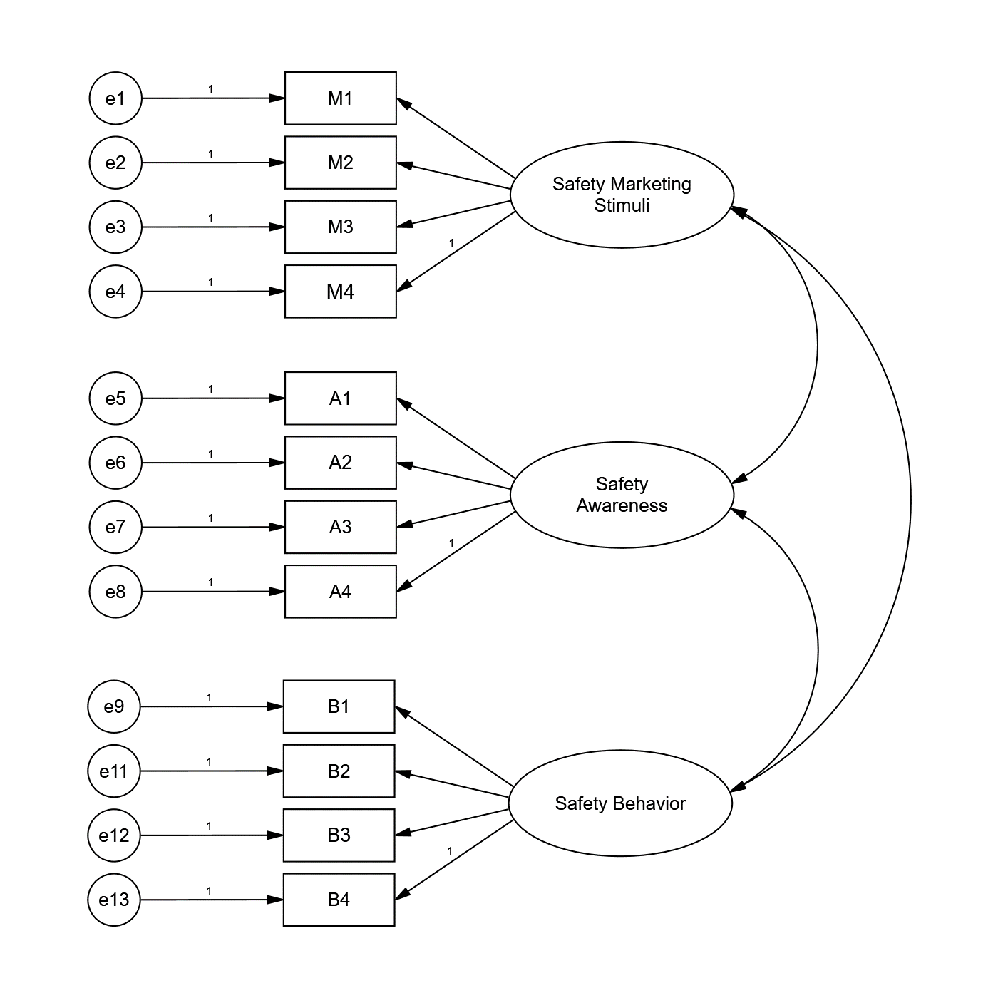

Figure 1: Example of an import meta file
Source: Author(s) of the original source (publication year)

Acknowledgements
Acknowledgements can be dedicated to those individuals or institutions who have made an important contribution to the paper but are not mentioned elsewhere in the paper. It should be placed after the conclusions and before the list of references.

References
References to original (NOT secondary) sources of cited materials should be listed together at the end of the paper in Harvard style. The list should be arranged in alphabetical order according to the last name of the first-named author without numbering. Some examples of reference in Harvard referencing style are listed below:

- For books
Surname, Initials (year), Title of Book, Publisher, Place of publication.
e.g. Stopford, M. (2009), Maritime Economics, Routledge, Oxon, UK.

- For book chapters
Surname, Initials (year), "Chapter title", Editor's Surname, Initials, Title of Book, Publisher, Place of publication, pages.
e.g. Lu, C. S., and Chang, P. H. (2015), " Choosing a business model of container terminal operations ", in Lee, C. Y. and Meng, Q. (Eds.), Handbook of Ocean Container Transport Logistics: Making Global Supply chains Effective, Springer, pp. 137-162.

- For journals
Surname, Initials (year), "Title of article", Journal Name, volume issue, pages.
e.g. Pang, K., and Lu, C.S. (2018), "A safety marketing stimuli-response model of passenger behavior in the ferry service’s context ", Maritime Business Review, Vol. 3 No. 4, pp. 36-52.

- For published conference proceedings
Surname, Initials (year of publication), "Title of paper", in Surname, Initials (Ed.), Title of published proceeding which may include place and date(s) held, Publisher, Place of publication, Page numbers.
e.g. Chang, Y. T., and Lee, S. (2019), "The impact of mergers and acquisitions on profitability and marketability of major airlines", in the 10th International Forum on Shipping, Ports and Airports (IFSPA) 2019, Hong Kong, pp. 490-509.

- For unpublished conference proceedings
Surname, Initials (year), "Title of paper", paper presented at Name of Conference, date of conference, place of conference, available at: URL if freely available on the internet (accessed date).
e.g. Aumueller, D. (2005), "Semantic authoring and retrieval within a wiki", paper presented at the European Semantic Web Conference (ESWC), 29 May-1 June, Heraklion, Crete, available at: http://dbs.uni-leipzig.de/file/aumueller05wiksar.pdf (accessed 20 February 2007).

- For working papers
Surname, Initials (year), "Title of article", working paper [number if available], Institution or organization, Place of organization, date.
e.g. Moizer, P. (2003), "How published academic research can inform policy decisions: the case of mandatory rotation of audit appointments", working paper, Leeds University Business School, University of Leeds, Leeds, 28 March.

- For encyclopedia entries (with no author or editor)
Title of Encyclopedia (year) "Title of entry", volume, edition, Title of Encyclopedia, Publisher, Place of publication, pages.
e.g. Encyclopaedia Britannica (1926) "Psychology of culture contact", Vol. 1, 13th ed., Encyclopaedia Britannica, London and New York, NY, pp. 765-71.

- For newspaper articles (authored)
Surname, Initials (year), "Article title", Newspaper, date, pages.
e.g. Smith, A. (2008), "Money for old rope", Daily News, 21 January, pp. 1, 3-4.

- For newspaper articles (non-authored)
Newspaper (year), "Article title", date, pages.
e.g. Daily News (2008), "Small change", 2 February, p. 7.

- For archival or other unpublished sources
Surname, Initials, (year), "Title of document", Unpublished Manuscript, collection name, inventory record, name of archive, location of archive.
e.g. Litman, S. (1902), "Mechanism & Technique of Commerce", Unpublished Manuscript, Simon Litman Papers, Record series 9/5/29 Box 3, University of Illinois Archives, Urbana-Champaign, IL.

- For electronic sources
If available online, the full URL should be supplied at the end of the reference, as well as a date that the resource was accessed.
e.g. Castle, B. (2005), "Introduction to web services for remote portlets", available at: http://www-128.ibm.com/developerworks/library/ws-wsrp/ (accessed 12 November 2007).

Appendices
Appendices should be placed right after the list of references. If there is more than on appendix, number each one consecutively.

The template is available in the next page.

International Forum on Shipping, Ports and Airports (IFSPA 2022)
Paper Template

Chin-Shan Lu¹, T.L. Yip¹, Dong Yang¹, and Stephen Lee¹

¹ Department of Logistics and Maritime Studies, The Hong Kong Polytechnic University, Hong Kong

Abstract
Purpose – INSERT the text here …

Design/methodology/approach – INSERT the text here …

Findings – INSERT the text here …

Research limitations/implications (if applicable) – INSERT the text here …

Practical implications (if applicable) – INSERT the text here …

Social implications (if applicable) – INSERT the text here …

Originality/value – INSERT the text here …

Keywords INSERT the text here …

- Introduction
INSERT the text . . . . . . . . . . . . . . .. More text here . . . . . . . . . . . . . . . . . . . . . More text here . . . The end of this text.

- Literature
INSERT the text . . . . . . . . . . . . . . .. More text here . . . . . . . . . . . . . . . . . . . . . More text here . . . The end of this text.

- Theoretical background and research hypotheses
3.1 An example of section heading
INSERT the text . . . . . . . . . . . . . . .. More text here . . . . . . . . . . . . . . . . . . . . . More text here . . . The end of this text.
3.1.1 An example of sub-section heading. INSERT the text . . . . . . . . . . . . . . .. More text here . . . . . . . . . . . . . . . . . . . . . More text here . . . The end of this text.

- Methodology
INSERT the text . . . . . . . . . . . . . . .. More text here . . . . . . . . . . . . . . . . . . . . . More text here . . . The end of this text.

- Empirical analyses results
INSERT the text . . . . . . . . . . . . . . .. More text here . . . . . . . . . . . . . . . . . . . . . More text here . . . The end of this text.

Table 2: Example of a table
IFSPA
1 km | 2 kg | 3 TEUs | 4 nm
1 km | 20 kg | 200 TEUs | 300 nm
3 km | 30 kg | 30 TEUs | 30 nm
Source: Author(s) of the original source (publication year)

- Discussion and implications
INSERT the text . . . . . . . . . . . . . . .. More text here . . . . . . . . . . . . . . . . . . . . . More text here . . . The end of this text.

- Limitations and directions for future research
INSERT the text . . . . . . . . . . . . . . .. More text here . . . . . . . . . . . . . . . . . . . . . More text here . . . The end of this text.

Acknowledgements (if any)
INSERT the text . . . . . . . . . . . . . . .. More text here . . . . . . . . . . . . . . . . . . . . . More text here . . . The end of this text.

References
Capizzi, M.T. and Ferguson, R. (2005), "Loyalty trends for the twenty-first century", Journal of Consumer Marketing, Vol. 22 No. 2, pp. 72-80.
Moizer, P. (2003), "How published academic research can inform policy decisions: the case of mandatory rotation of audit appointments", working paper, Leeds University Business School, University of Leeds, Leeds, 28 March.

Appendix (if any)
INSERT the text . . . . . . . . . . . . . . .. More text here . . . . . . . . . . . . . . . . . . . . . More text here . . . The end of this text.

