Application for Waiver of Education on
“Understanding China and Hong Kong Special Administrative Region, P.R.C.”
(for Research Postgraduate Students from the 2022/23 intake cohort onwards)
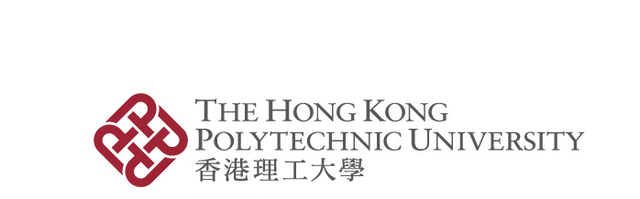
Please read the information below before completing this form.

- Applicant's Particulars
Name: |  | Department/School:
Student No.: |  | Contact Number:
Programme: | □ MPhil □ PhD □ Dual PhD  □ Joint PhD Supervision Programmes Leading to a PolyU Degree | Programme Code & Subcode: | -
- Application Details

Apply for the waiver of | For the Office of Undergraduate Studies (OUS) Use Only
❒ Education on “Understanding China and Hong Kong Special Administrative Region, P.R.C.” | Accept / Reject*
  Signature: |  | Date:

I have attached to this form copies of the documents in support of the qualification on the basis of which waiver of education on “Understanding China and Hong Kong Special Administrative Region, P.R.C.” requirement is claimed.
I declare that the information provided in this application is complete and true to the best of my knowledge and the grade used for the application was attained in the last attempt of my previous study. I authorise the University to verify the data provided in this application where necessary. I also understand that any false information given in this application will result in the nullification of the application or its approval.

Signature: |  | Date:

Notes:
- Please read carefully the education on “Understanding China and the Hong Kong Special Administrative Region, P.R.C.” for RPg students and guidelines on the application for the waiver of the “Understanding China and HKSAR, P.R.C.” for Postgraduate Students on the OUS website (https://www.polyu.edu.hk/ous/nationaleducation/understanding-china-and-hongkong/) before completing this form.
- Please attach to this form copies of the documents in support of the qualification on the basis of which waiver of education on the “Understanding China and Hong Kong Special Administrative Region, P.R.C.” requirement is claimed. Original copies should be provided for verification when required.
- The completed form should be submitted to the Director of Research Postgraduate Studies (DoRPgS) of the host Department/School, preferably before the start of a new semester/term and not later than the end of the add/drop period for the semester/term concerned. Upon receipt of the form from the student, the DoRPgS via the D/SRC Secretary should pass the form to OUS. For enquiries, please contact OUS at ous.enq@polyu.edu.hk or 3400 8203.
- Students will receive a notification on the result of their application from the host Department/School normally within 14 days from the date of submission.
- Please note that the information given in this form will only be used for processing this application.

(*Please delete as appropriate)

