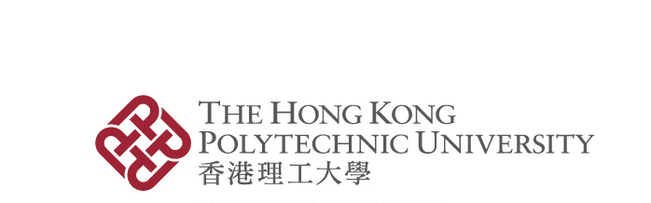
Application for Certified True Copy
(for Research Postgraduate Graduates/Leavers)

Please read the information overleaf before completing this form.

- Applicant's Particulars
Name: |  | Department/School:
Student no.: |  | Year of Graduation:
Programme: | ◻ MPhil ◻ PhD  ◻ Dual PhD  ◻ Joint PhD Supervision Programmes Leading to a PolyU Degree | HKID Card/Passport/ Mainland ID*:
Email Address: |  | Contact Number:
Address:

- Purpose of The Certified True Copy (see Note 1)

 |  | Purpose | No. of copies

- Recipient(s) Information (see Note 3)

 | ◻ | I will collect the certified true copy in person.
 | ◻ | I will authorise another person to collect the certified true copy on my behalf.

Signature: |  | Date:

Application received by: |  | on
Checked by: |  | on
Certified by: |  | on
Informed by: |  | on
Certified True copy and the original parchment collected by: |  | on

*Please delete as appropriate.
Please “✓” the appropriate boxes
Notes:

- Only award parchments issued by The Hong Kong Polytechnic University (formerly the Hong Kong Polytechnic) will be accepted for certification. Normally, the University will only certify one copy for each application. Additional copies will only be entertained under exceptional circumstances with justifiable grounds. The normal processing time is around 3 weeks.

- Applicants should complete the form together with the original parchment to the Graduate School in person or by authorised person.

- If you authorise another person to collect the certified true copy on your behalf, please provide a letter of authorisation and a copy of your HKID Card/Passport/Mainland ID card which should tally with the student record kept by PolyU. The copy of your ID document will be destroyed after processing your application.

- The information given in this form will only be used for processing this application.

