LAND BOUNDARY SURVEY OF
INLAND LOT 2366 S.GG ss.4 & Ext., S.GG ss.5 & Ext. AND S.GG RP & Ext.

1. Introductions

To re-establish the land boundary of Inland Lot Nos. 2366 S.GG ss.4 & Ext., S.GG ss.5 & Ext. AND S.GG RP & Ext. for the Incorporated Owners of Maple Gardens III (楓林花園第三期).

2. Land Record Search

To carry out the land record search at the relevant Government Departments and information collection from the lot owners / occupants.

District Survey Office/Hong Kong (DSO/HK)

Obtain the following information from DSO/HK:

- Lot Index Plan No. 11-SE-6B (Appendix A2)
- Setting Out Plan No. HK1459 S2 (Appendix F)
- Setting Out Plan No. HK1459 S3 (Appendix G)
- Computation Folder No. S1, DSO/HK (Appendix H1)
- Computation Folder No. L445, DSO/HK (Appendix H2)
- Computation Folder No. L619, DSO/HK (Appendix H3)
- Computation Folder No. HK1459I, DSO/HK (Appendix H4)
- Computation Folder No. HK1459II, DSO/HK (Appendix H5)
- Computation Folder No. HK1459III, DSO/HK (Appendix H6)
- Control Traverse: Minor Traverse No. 2067 (Appendix I)

Land Registry

Obtain the following information from Land Registry or via on-line order https://www.iris.gov.hk/eservices/:

- Land Register of IL2366 S.GG ss.3 S.A & Ext. (Appendix C1)
- Land Register of IL2366 S.GG ss.4 & Ext. (Appendix C2)
- Land Register of IL2366 S.GG ss.5 & Ext. (Appendix C3)
- Land Register of IL2366 S.GG RP & Ext. (Appendix C4)
- Land Register of IL2366 RP & Ext. (Appendix C5)
- Plan annexed to Condition of Sales No. UB1143 (Appendix D)
- Plans annexed to various Memorials (Appendices E1-E143)

3. Site Visit and Planning

Before commencing the field survey, site visit should be undertaken in order to get familiar with the local and nearby areas. This might help to design the control network and the time would be used for the observations.

During the design stage, the route/path of the control traverses, the number and the position of control stations must be considered.

4. Instrumentation Preparation

The validity of calibration of the surveying instrumentation must be checked before using. It is also recommended to undertake a quick checking for the instruments on site before taking observations, for example, the consistence between the face left and face right readings of an observed point from the total station.

5. Field Surveying

Traverse Network Establishment

- Traverse shall start from geodetic survey stations or survey stations which are the survey marks over which survey observations are made in connection with land boundary surveys submitted to the Land Survey Authority under Land Survey Ordinance or land boundary surveys carried out by the Survey and Mapping Office of Lands Department (i.e. title stations). This is either a trigonometric or traverse station.

- Before any traverse begins, the reliability of the survey stations used for an origin should be proved by the surveyor. Closing rays should be considered as second origins. The reliability of the survey stations used for closing rays and coordinates should be proved by using the same methods as for origins.

- No unclosed traverses are allowed.

Under the subject survey, the new traverse stations were originated from OUSM2067.071 and closed on OUSM2067.072.

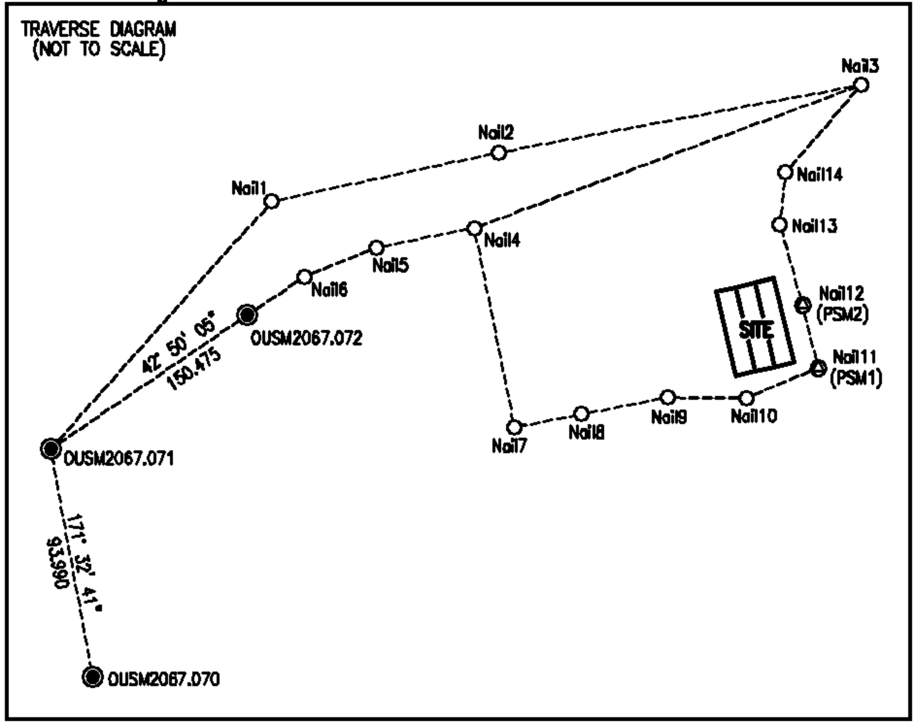

After a satisfactory test of origin, two new traverses were run to near the limits of the subject lots. Two new PSMs, Nail11(PSM1) and Nail12(PSM2) which were both at ground level, were established for future survey reference.

Please refer to “Code of Practice” of “Land Survey Ordinance (Chapter 473)” for detailed requirements.

Observation of Physical Features

All physical features relevant to the lot to be redefined and its adjoining and nearby lots should be observed by total station. Measuring tape might be used for measurements whenever not observable by Total Station or for checking purposes.

A 24-storey building, Maple Gardens III, is erected on the subject lots whilst a 4-storey semi-detached building is erected on the eastern adjoining lot IL2366 S.GG ss.6 & Ext. Besides, a 23-storey building, Maple Gardens Phase II, is erected on the western adjoining lots IL2366 S.CC ss.1 RP & Ext., ss.2 RP & Ext., ss.3 RP & Ext., S.GG ss.1 RP & Ext., ss.2 RP & Ext. and ss.3 RP & Ext.

The southern sides of the subject lots are adjoining with a slope which was re-constructed by Architectural Services Department (ASD) about four years before and Kiangsu Chekiang School Nursery KG Primary & International Section is situated at the top of the said slope (i.e. IL7330).

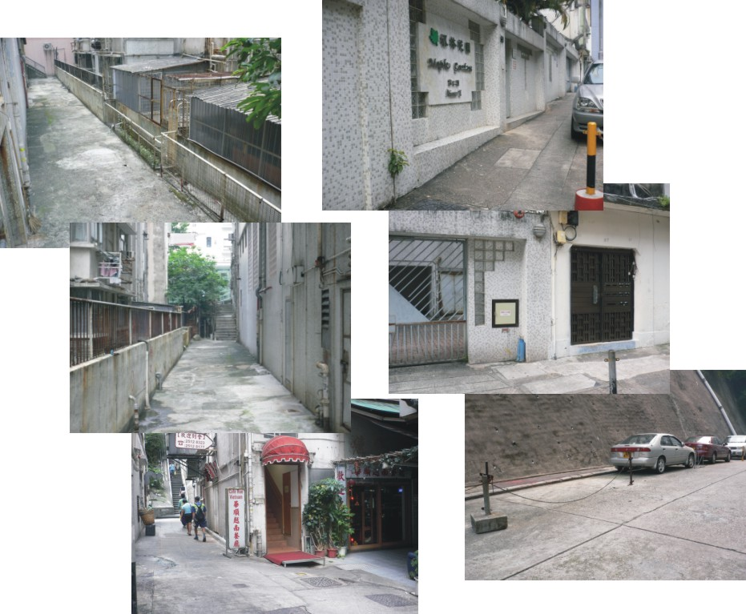

Other ground features to be surveyed should include but not limited to the following items.

- Field bund
- Boundary wall / party wall
- Fence / hoarding
- House / Building structures
- Gate

- Root of ruined walls
- Edge of platform
- Cutting
- Channel
- Temporary structures
- Boundary stones

Field Sketch

Sketch shall clearly show the detailed configuration of the surveyed features with observed point numbers. Observations by tie measurements, such as width and height of walls, fences, etc. and other relevant information such as age, belongings, etc., shall be clearly indicated on the sketch.

Add Scan here
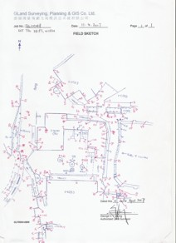
(Figure D1)

Field Notes

The following requirements are extracted from “Code of Practice” of “Land Survey Ordinance (Chapter 473)”:-

- Field notes shall be prepared for all land boundary surveys and should be a complete original record of all field observations and field measurements recorded in the field.

- Field Notes shall record the type and serial number of the instruments used for the survey. The first page shall show the designation of the land parcel, locality or such other reference or legal descriptions. The date of starting and completing the survey shall be recorded.

Photographic Records

Photographs should be taken for those critical features for record purposes. This is important especially along those boundary positions as these features might be changed, removed, disturbed or destroyed. The photographs taken might become some kind of evidence in case of any boundary conflict in the future.

Local Enquires

Local enquires should carry out for the owner / occupant of the lot and the nearby areas. Usually, aged occupants and indigenous villagers may tell the position of the boundaries even there are physical changes to the site. These collected information might form part of the evidences during the boundary redefinition stage.

According to the occupants of the subject lots (i.e. the various registered owners of Maple Gardens III), the building was constructed in early 1990s and some of the registered owners have been living in the building since then. Improvement works were undertaken by ASD for the slope at the southern side of the subject lots about 4 years before. Further to the completion of the slope improvement works, some trespassed vehicles occupied the land at the southern side of the subject lots (i.e. at Kin Wah Street).

The registered owners explained that the construction fee for the above mentioned slope improvement works was shared by the subject lots and the southern adjoining lot IL7330 since the slope fell within the boundaries of the said lots. Under this circumstance, they truly believed that the common boundary position between the subject lots and IL7330 should be located somewhere within the slope area.

6. Data Downloading

Upon the completion of the field surveying works, the data should be downloaded to the computer by the end of the day. It is recommended that the data should be downloaded daily if the field surveying works in order to avoid accidental lost or instrumentation failure. It is also recommended that a copy of the downloaded data should be saved in some other designated path in the network for backup purpose.

- Download the collected data to computer;
- Make a copy of the downloaded data to the designated path in network;

7. Traverse Computation, Data Reduction and Drafting

Before the reduction of the observations (i.e. observed points), the control traverse network must be firstly calculated. The downloaded data will then be reduced by surveying software. This is actually converting the angles and distances of the observed points to co-ordinates based on the reduced traverse control network.

- Reduce the traverse(s) manually or with surveying software by Bowditch Method;
- Reduce the observed data manually or with surveying software;

The misclosure of reduced traverse should not exceed the following tolerance.

Angular Misclosure : 30 √ n (seconds)
(where n is the number of survey stations in the traverse)

Linear Misclosure : 10 + 2S / 15 (mm)
(where S is the total length of the traverse in metres)

Upon the completion of the data reduction, a “working diagram” which shows all the joined points and symbolic lines should be drafted. The working diagram should also show other basic information such as the age of the features, type of features (if necessary), lot numbers, traverse information, etc. for ease of reference.
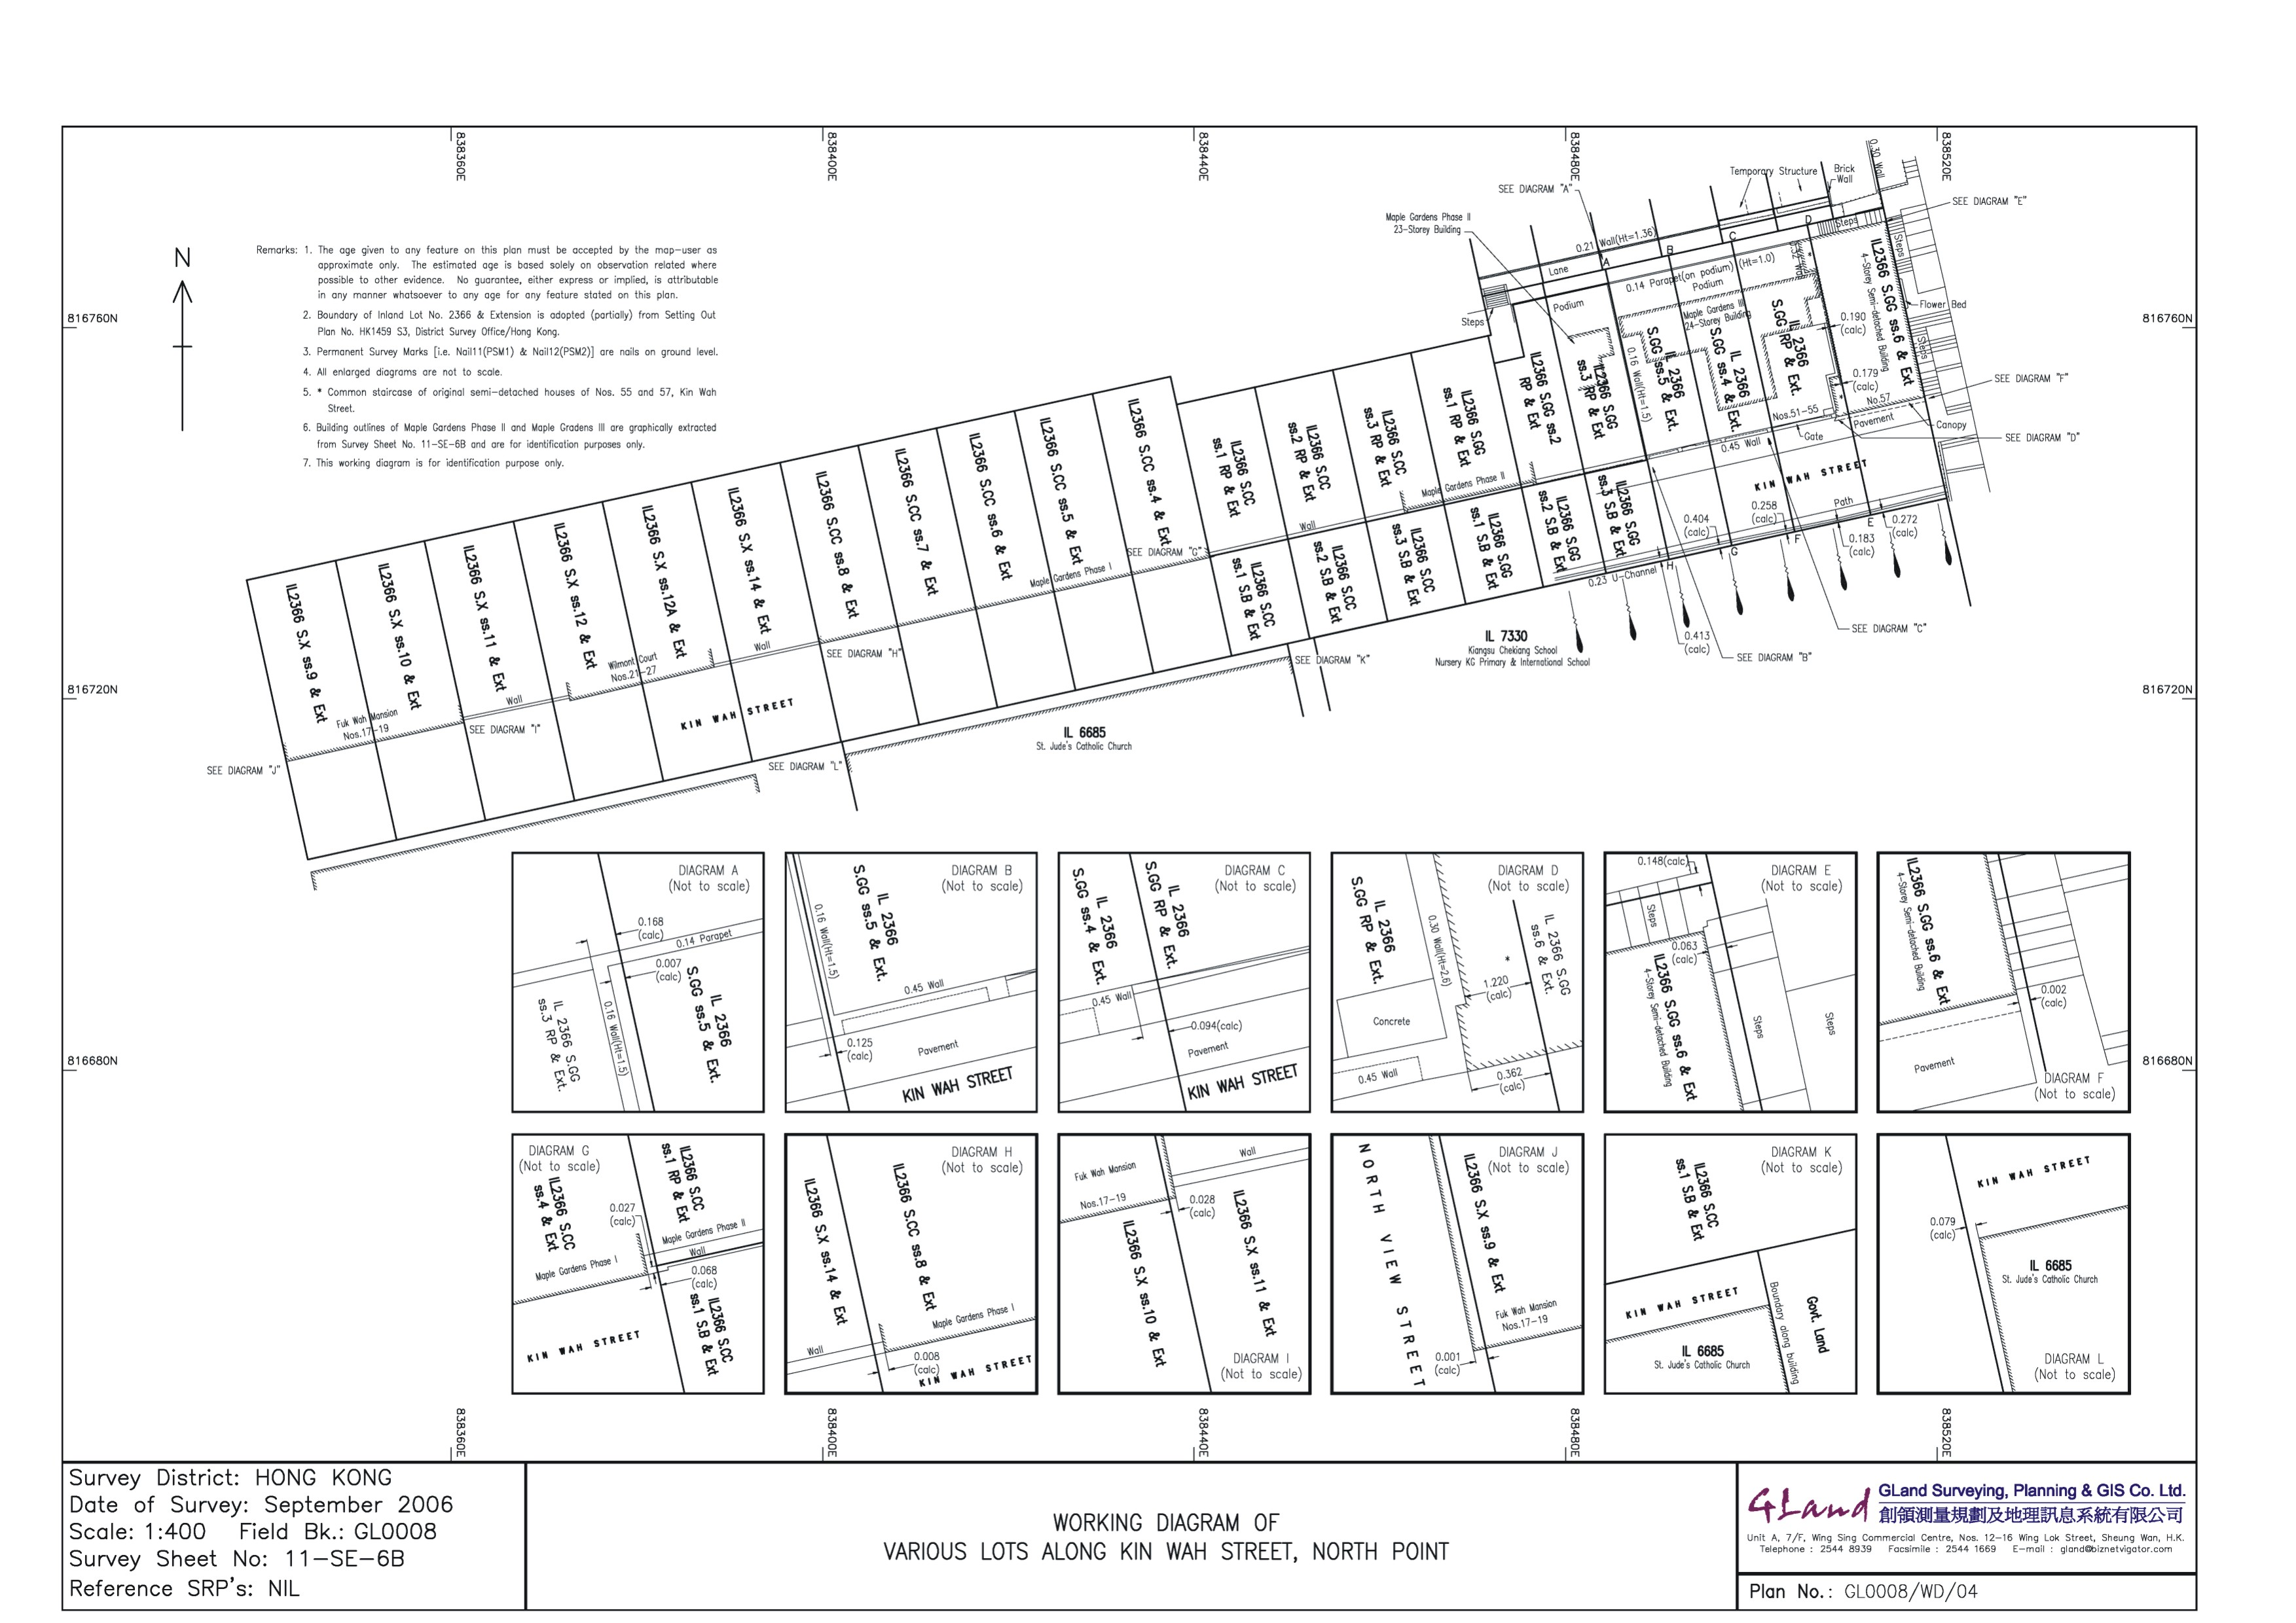

8. Field Checking

Field checking should be undertaken upon the completion of the field works and drafting. The produced working diagram should be taken onto the field for checking purposes. Any discrepancy found should be marked on the working diagram.

Besides, any outstanding or missing ground features should be measured and added by means of tie measurements or total station observations. Additional photographs may be taken for record purposes.

9. Boundary Interpretations

Further to the field survey works and office computations, the boundary of the lot will then be re-established based on the various cadastral records and the surveyed physical features.

Background Interpretation

In the subject case, the history of the lots and their parent lot should be clarified as follow:

- A carving out history diagram should be prepared to identify the relationships between the parent lot and the divided sections and sub-sections. This is done by comparing the relevant assignment plans or division plans.

- The dimensions of the divided sections and sub-sections should be compared against the corresponding parent lots. The total area of the divided sections and sub-sections should be compared against the original area of the corresponding parent lot.
- In case of curvature boundary, the radius (and centre if applicable) of the adjacent lot/section should be compared.
- In case of discrepancy found, the reliability of the uncertainty must be clarified.
- Please note that there was no standard for the designation of the divided sections / sub-sections before the enactment of the Land Survey Ordinance (Chapter 473) in 1996. Hence, the designations of the divided sections in the subject case did not following the rules as stated in the said Ordinance (e.g. S.A, S.B, S.C, ….. S.Y, S.Z, S.AA, S.BB, S.CC, …, etc.).
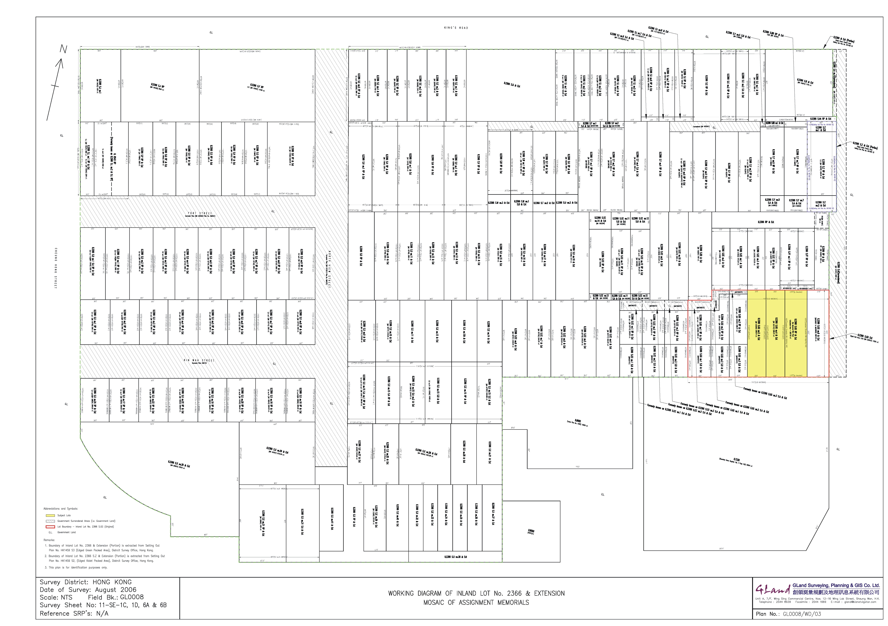

Lot History

The parent lot, Inland Lot 2366, was sold under the Condition of Sale No. UB1143 and was held under a 75 years lease term commencing from 13/1/1922 with renewable for 75 years. The sold area was about 412,000 sq. ft.

An extension was granted to Inland Lot 2366 (i.e. in terms of the parent lot) and was subsequently subdivided in various sections namely Inland Lot 2366 S.A, S.B, ……, S.Y, S.Z, S.AA, S.BB, S.CC,…., S.FF, S.GG and RP (i.e. without AB, AC,…, BA, BC, etc.). Most of these sections were further subdivided into Sub-sections and Sections and more than 320 sections or subsections were currently existed under Inland Lot 2366 (IL 2366) & Extensions.

Various resumption and surrender exercises were undertaken in different years for the back lanes and along North View Street, Fort Street and Kin Wah Street. Strata resumptions were also undertaken for those sections or subsections which involved in the extension of Tseung Kwan O Line (i.e. Quarry Bay Congestion Relief Works) of Mass Transit Railway via Memorial No. UB7260272 (Appendix E143) (G.N.713 of 1997).

IL 2366 S.GG & Ext. (i.e. Memorial No. UB226916 – Appendix E117) was carved out from the then IL 2366 RP & Ext. and was subdivided into IL 2366 S.GG ss.1 to ss.6 and RP & Ext. (i.e. 7 subsections). The dimensions and areas of IL 2366 S.GG ss.4 & Ext. (Memorial No. UB243116 – Appendix E124) and IL 2366 S.GG ss.5 & Ext. (Memorial No. UB242590 – Appendix E123) are both 105′ 0″ × 22′ 9″ = 2388.75 sq. ft. However, there was no assignment plan annexed to the Memorials of IL 2366 S.GG RP & Ext. of which the dimensions of the northern and southern boundaries (i.e. 27′ 6″) can only be derived by deduction method (i.e. reducing the dimensions of other subsections of IL 2366 S.GG) whilst the dimensions of the eastern and western boundaries are adopting from the adjoining lots. The resultant area of IL 2366 S.GG RP & Ext. is 2887.50 sq. ft. (i.e. 105′ 0″ × 27′ 6″) and is equal to those of the eastern adjoining IL 2366 S.GG ss.6 & Ext. However, there was no resumption exercise previously undertaken for the subject lots.

The total dimension of the northern boundaries of IL 2366 S.GG ss.2 to ss.6 and RP & Ext. are checked and are found to be consistent with the total dimension of the southern boundaries of the northern adjoining IL 2366 S.EE ss.1 to ss.3 and RP & Ext., S.FF ss.1 and S.FF RP & Ext. (i.e. prior to the surrender exercise, Surrender Plan Nos. HK1459 SU1 and HK1459 SU2) and IL 2366 RP & Ext. The dimensions and areas of the subject lots are tablet as follows.

Lot No. | Dimensions | Registered Area
IL2366 S.GG ss.4 & Ext. | 105′ × 22′ 9″ | 2388.75 ft²
IL2366 S.GG ss.5 & Ext. | 105′ × 22′ 9″ | 2388.75 ft²
IL2366 S.GG RP & Ext. | 105′ × 27′ 6″  (by deduction) | 2887.50 ft²  (by calculation)

As shown on the assignment plans of IL 2366 S.GG ss.4 and ss.5 & Ext. [i.e. Memorial Nos. UB243116 (Appendix E124) and UB242590 (Appendix E123)], a 36′ 0″ “Right of Way” (i.e. Kin Wah Street) and a 5′ 0″ “Scavenging Lane” (i.e. back lane) are at the southern and the northern sides of the two lots respectively. The widths of these easements are consistent with those of the adjoining lots along Kin Wah Street.

On the other hand, IL 2366 S.FF ss.1 S.A & Ext. and S.FF ss.2 & Ext. were surrendered to the Government with Surrender Plan Nos. HK1459 SU1 and HK1459 SU2. However, there was no survey undertaken for such surrender exercise (C/F No. HK1459 I refers). IL 2366 S.CC ss.1 to ss.3 & Ext. and S.GG ss.1 to ss.3 & Ext. were subdivided into S.As, S.Bs and RPs via Memorial No. UB4024151(Appendix E141) and were under the Agreement for Surrender. In 1997, the subdivided S.As of the said lots were surrendered to the Government via Memorial No. UB7260272 (Appendix E143).

Evaluation of Boundary Evidence and Previously Re-established Boundaries

According to the record search at District Survey Office/Hong Kong (DSO/HK) and the Land Registry, it was noted that the boundaries of IL 2366 S.Z & Ext. (i.e. currently designated as IL 2366 S.Z ss.1, ss.2 and RP & Ext., Photograph No. 9, Appendix N) and IL 2366 & Ext. (Portion) [i.e. the peripheral extents of IL 2366 & Ext.] were previously defined and set out on ground by the said office in 1980s and the boundary data were recorded on Setting Out Plan Nos. HK1459S2 and HK1459S3 (Appendices F and G) respectively. Furthermore, assignment plans of the subdivided sections and subsections of IL 2366 & Ext. were obtained from Land Registry in order to form the mosaic of lots for IL 2366 & Ext.

From the interpretation of the above mentioned defined boundaries, conflict was found at boundary point C of IL 2366 S.Z & Ext. (SOP: HK1459S2) and boundary point E of IL 2366 & Ext (SOP: HK1459S3) which should be the common boundary point of IL 2366 & Extension. However, no error was found from the bearing and distance calculations as shown on the said plans. Hence, the reason why the discrepancy appeared is untraceable.

The defined eastern and western boundary dimensions of IL 2366 S.Z & Ext (i.e. 110′ 0″ or 33.528 m) are found to be consistent with those as shown on the assignment plan (Memorial No. UB183765 – Appendix E50). However, the defined northern and southern boundary dimensions (i.e. 11.878 m) are slightly less than those of the assignment plan (i.e. 39′ 0″ or 11.887 m) by 9 mm. On the other hand, the defined eastern boundary dimensions of IL 2366 S.B & Ext (i.e. 25.856 m) and S.AA RP & Ext. (i.e. 1.642 m, the distance between boundary point D of IL 2366 & Ext. and boundary point B of IL 2366 S.Z & Ext.) are different from those as shown on the assignment plans of IL 2366 S.B & Ext. (i.e. 85′ 0″ or 25.908 m – Memorial No. UB150815 – Appendix E2) and S.AA RP & Ext. (i.e. 5′ 0″ or 1.524 m, the width of the scavenging lane) respectively.

Furthermore, it is also found that the distance between the northern and the southern boundary lines (i.e. boundary lines A-B and G-H: about 123.297 m) of IL 2366 & Ext. is larger than the dimension as shown on assignment plan of IL 2366 S.A (i.e. 400′ 0″ or 121.920 m – Memorial No. UB127341 – Appendix E1) by about 1.377 m.

Under the subject survey, the whole block of lots along Kin Wah Street were surveyed. By superimposing the above mentioned defined boundaries onto the surveyed features, it was found that the defined boundary line G-H (i.e. HK1459S3) was mostly consistent with the surveyed northern building outline of St. Jude’s Catholic Church (i.e. IL6685) whilst boundary line F-G was also consistent with the eastern building outline of No. 57 Kin Wah Street (i.e. IL 2366 S.GG ss.6 & Ext.).

According to the result of the subject survey, the dimensions of the buildings in the vicinity of the subject lots as well as the width of the scavenging lane (i.e. 5′ 0″) and Kin Wah Street (i.e. 36′ 0″) were consistent with those as shown on the corresponding assignment plans. However, it was proved that the actual north-southerly dimension of IL 2366 & Ext. (i.e. distance between King’s Road and Kin Wah Street) is much larger than those of the assignment plans (i.e. 400′ 0″). It was also noted that the northern boundaries of IL 6685 and IL 7330 should be aligned with the boundary of IL 2366 & Ext. (i.e. common boundary line without gaps between) from the intention of grant. Under this circumstance, it was believed that the said boundaries of IL 2366 & Ext. were defined by adopting the boundary dimensions as shown on the assignment plans as the boundary reference information on one hand, and by adopting the existing occupations in majority on the other hand.

From the above findings, in case of adopting the defined boundary line G-H of IL 2366 & Ext., the southern boundaries of the subject lots would fall within the slope area by more than 1.5 m. at the south and the 5′ 0″ scavenging lane of the subject lots would totally fall within the building area of the subject lots if the original dimension (i.e. 110′ 0″) was adopted (Working Diagram No. GL0008/WD/04 - Appendix M2 refers). Furthermore, it would not be appropriate to redefine the boundaries of the subject lots by adopting the said defined boundary line G-H of IL 2366 & Ext. and retaining the said 5′ 0″ scavenging lane in open area at the north of the subject lots (i.e. to extend the lot dimension) which resulted excesses to the surveyed areas without legal background.

The boundaries of IL 6685 (i.e. C/F No. L445, DSO/HK) and IL 7330 (i.e. C/F No. L619, DSO/HK) were also provisionally redefined. This was done by firstly converting the boundary data of the two lots from Old Imperial Grid values to metric units, by adopting the conversion constants (N=+0.083m; E=-0.002m, C/F No. HK1459I refers) to HK1980 Grid values (i.e. SV672 to SV797) and by the constant (N=-0.002m; E=+0.010m) between the old values of OUSM2067.028 and the current values of OUSM2067.076. The result affirmed that the east-westerly alignment of the redefined boundary lines of the two lots were not consisted with DSO/HK defined boundary (i.e. boundary line G-H) of IL 2366 & Ext. but was close to the alignment which was 36′ 0″ offset from the boundary walls of the lots along the northern side of Kin Wah Street.

10. Boundary Re-establishment

From the above interpretations and findings, it was therefore concluded that the boundaries of the subject lots should be redefined by partially adopting the defined boundaries of IL 2366 & Ext., by adopting the assignment dimensions and areas of the corresponding lots in majority, by adopting the bearing of the defined boundaries of Kin Wah Street, and by adopting the existing occupations of the subject lots.

The eastern boundary line of IL 2366 S.GG ss.6 & Ext. is firstly aligned with the defined boundary of IL 2366 & Ext. (i.e. bearing 167°40’10”, boundary line F-G, SOP: HK1459S3). The northern boundary alignment of the subject lots (i.e. boundary lines A-B-C-D under the subject redefinition), IL 2366 S.GG ss.6 & Ext., S.GG ss.2 and ss.3 & Ext. are then defined by adopting the dimensions as shown on the assignment plans of IL 2366 S.B & Ext. (i.e. 85′ 0″ or 25.908m, Memorial No. UB150815), IL 2366 S.AA RP & Ext., (i.e. 5′ 0″), IL 2366 S.Z & Ext. (i.e. 110′ 0″ or 33.528m, Memorial No. UB183765 and SOP: HK1459S2) and IL 2366 RP & Ext. (i.e. 95′ 0″ or 28.956m, Memorial No. UB244981) originated from the defined boundary point B of IL 2366 & Ext. (i.e. along King’s Road, SOP: HK1459S3 refers) on one hand, and by adopting the common bearing 77°33’10” of Kin Wah Street (i.e. IL 2366 & Ext, IL 6685 and IL 7330) on the other hand. Boundary lines D-E, C-F, B-G and A-H are defined by adopting the dimensions as shown on the corresponding assignment plans offsetting from the defined eastern boundary line of IL 2366 S.GG ss.6 & Ext. Finally, the southern boundary lines E-F-G-H, instead of adopting the defined boundary line G-H of IL 2366 & Ext., are defined by adopting the dimensions (i.e. 110′ 0″ or 33.528m) as shown on the corresponding assignment plans offset from the defined northern boundaries of the subject lots. In other words, the common bearing 77°33’10” of Kin Wah Street is also adopted.

The defined boundary lines of the subject lots are found to be mostly consistent with the surveyed features such as the common boundary walls with the adjoining IL 2366 S.GG ss.3 RP & Ext. (Maple Gardens Phase II). The defined boundary line D-E is also close to the centreline of the surveyed staircases (Photograph No. 8, Appendix N) and party-wall (i.e. Memorial No. UB256857 – Appendix E127) of the eastern semi-detached house. Furthermore, the distance between the boundary walls (i.e. along Kin Wah Street) and the defined southern boundary (i.e. Boundary line E-F-G-H) of the subject lots are consistent with the width of Kin Wah Street as well as the converted boundaries of IL 6658 and IL 7330 as mentioned above in the last paragraph of Section 7.

Under the subject survey, the other lots along Kin Wah Street are also provisionally redefined by adopting the assignment dimensions and the results affirmed that the redefined boundaries are mostly consistent with the surveyed features especially the eastern and western ends of the block (Working Diagram No. GL0008/WD/04 - Appendix M2 refers).

Despite that some minor discrepancies were spotted in regards of physical locations and defined boundaries of the subject lots, in general, were reliable and in a consistent manner as far as the analysis was concerned. These minor discrepancies might due to various reasons such as inaccuracy during the division exercise, for example, paper subdivision and assignment without actual field survey or boundary verification. The assignment plans, nevertheless, were properly documented and no remarkable contradiction was found during the subject land boundary survey.

11. Registered Area vs. Surveyed Area

The comparison between the registered area and the surveyed area is necessary in order to determine whether the surveyed area is reasonable.

Under the redefinition, the surveyed areas and dimensions of the subject lots are agreeable to those as shown on the corresponding assignment plans. These areas and dimensions are tabulated below for reference.

Lot No. | Dimensions | Registered Area | Surveyed Area
IL2366 S.GG ss.4 & Ext. | 105′ × 22′ 9″ or 32.004 m × 6.934 m | 2388.75 ft² or 221.9 m² | 221.9 m² (about)
IL2366 S.GG ss.5 & Ext. | 105′ × 22′ 9″ or  32.004 m × 6.934 m | 2388.75 ft² or 221.9 m² | 221.9 m²(about)
IL2366 S.GG RP & Ext. | 105′ × 27′ 6″ or  32.004 m × 8.382 m  (by deduction) | 2887.50 ft² or  268.3 m²  (by calculation) | 268.3 m² (about)

12. Plans Production

Once the boundary is re-established, the boundary lines might be superimposed onto the produced working diagram and formed the “survey record plan” for survey record purpose. Meanwhile, a Dimension Plan (No. SRP/HK/054/0008-01/D1) should also be prepared for land record purpose.

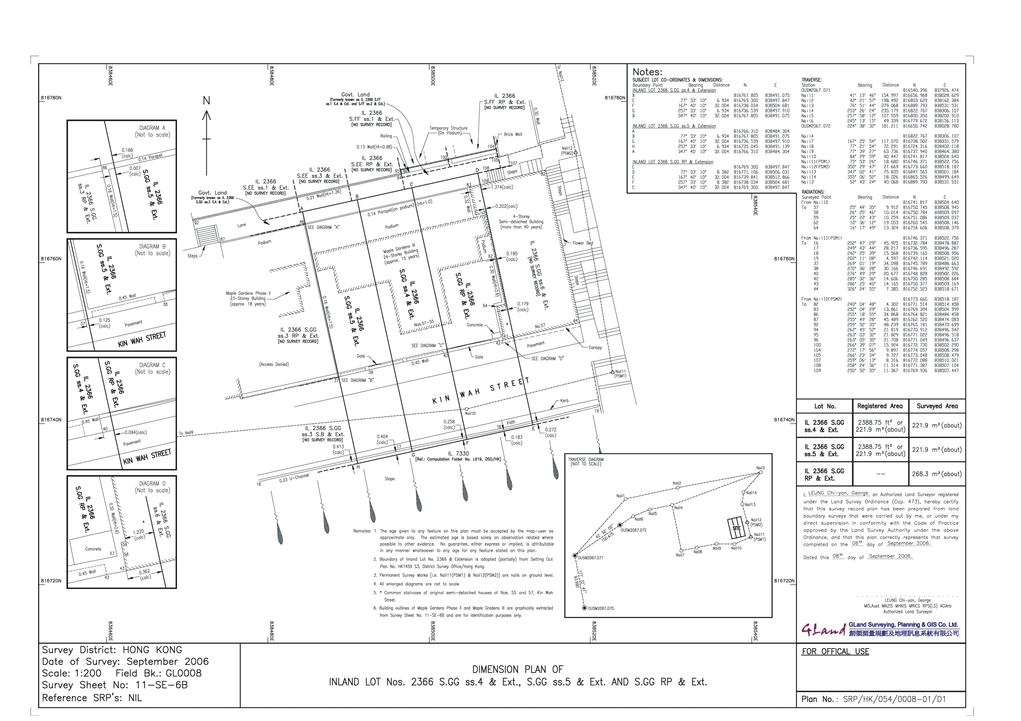

Please refer to the sample survey record plan and land boundary plan annexed to the “Code of Practice” of “Land Survey Ordinance (Chapter 473)” for reference.

13. Report Writing

The final step in a land boundary survey exercise was to prepare a land boundary survey report. Due to the limited space of the produced survey plans, a land boundary survey report will illustrate the reasoning and evidences used in defining the lot boundary. The report will explain the detailed information which includes the purpose, background, the documentary evidence collected, studied and used, the field survey exercise, the verification of various cadastral records and evidences, the conclusions being made, etc.

The survey report should bear the certification of the land surveyor.

Please refer to the “Recommended Format for Survey Reports” annexed to the “Code of Practice” of “Land Survey Ordinance (Chapter 473)” for reference.

