Evaluation Report on the Pilot Implementation of Bring Your Own Device (BYOD)

- Participants

In the academic years 2014/15 and 2015/16, 173 students at the PolyU and the HKIEd were invited to join the BYOD project through convenience sampling. They were provided with opportunities to explore and learn with various eResources and to interact with peers and the class teacher. A total of 143 PolyU students enrolled on the ELC1014 Advanced English for University Studies course gave their written consent to participate in the project. ELC1014 is a credit-bearing subject that requires students to research for, write, plan and revise a 1200-word academic position argument essay, and to defend their views and engage with those of others clearly and logically in a mini oral defence. Similarly, written consent was secured from 30 HKIEd students reading for a Bachelor of Science Education (Honours). They were enrolled on the INT3026 Internetworking and Web Server Administration course. INT3026 is a credit-bearing subject that requires students to complete all in-class exercises and develop an individual project on establishing a Web server to host a Web application.

- 2014/15, Semester 2, BYOD Pilot Stage, PolyU
Experimental ELC1014 Groups |  |  |  | Control ELC1014 Groups
Programme of Study | No. of Participants | No. of class observations |  | Programme of Study | No. of Participants | No. of class observations
School of Hotel, Tourism Management (SHTM), higher diploma | 14 | 2 |  | Radiography (RAD), degree | 14 | 1
Applied Biology and Chemical Technology (ABCT), degree | 20 | 2 |  | Industrial System Engineering (ISE), degree | 14 | 1
Civil and Environmental Engineering (CEE), degree | 10 | 2
Total | 44 | 6 |  | Total | 28 | 2

- 2015/16, Semester 1, BYOD Full Implementation - PolyU
Experimental ELC1014 Groups |  |  |  | Control ELC1014 Groups
Programme of Study | No. of Participants | No. of class observations |  | Programme of Study | No. of Participants | No. of class observations
Accounting & Finance (AF) + CEE, degree | 15 | 1 |  | Radiography (RAD), degree | 24 | 1
Radiography (RAD), degree | 17 | 1 |  | School of Nursing (SN), degree | 9 | 1
School of Design (SD), higher diploma | 6 | 0
Total | 38 | 2 |  | Total | 33 | 2

- 2015/16, Semester 1, BYOD Full Implementation – HKIEd
Experimental INT3026 Group
Programme of Study | No. of Participants | No. of class observations
Internetworking and Web Server Administration (INT), degree | 30 | 1
Total | 30 | 1

- Data collection

- 2014/15, Semester 2, BYOD Pilot Stage, PolyU

In all, 72 students (44 in three experimental groups, 28 in two control groups) took part in the pilot stage. Quantitative and qualitative data were obtained from three sources: i-a) online user acceptance pre- (n=40) and post-(n=44) surveys; i-b) focus group interviews (five sessions with nine participants); and i-c) class observations (n=8).

Below is the online BYOD user acceptance survey administered to participating students at the beginning (pre-) and the end (post-) of the semester. It asked students to check the box that best described their BYOD attitude, namely, Strongly disagree=1, Disagree=2, Neutral=3, Agree=4, Strongly agree=5.

Online BYOD User Acceptance Survey
Item
PU1. | BYOD helps me learn more effectively.
PU2. | BYOD enables me to complete my assignments more quickly.
PU3. | BYOD improves my course performance.
PU4. | I find BYOD useful to my learning.
PEU1. | Using my own device for learning is easy and straightforward.
PEU2. | I find my own device easy to use.
PEU3. | The BYOD learning resources and platforms are easy to access and use.
PEU4. | It is easy for me to become skillful at using my own device for learning.
ABL1. | Using my own device for both in-class and out-of-class activities is helpful for learning.
ABL2. | Being able to use my own device for learning stimulates my interest in this course.
ABL3. | I enjoy using my own device for learning.
BIBL1. | I intend to use my own device for learning during the semester.
BIBL2. | I intend to use my own device for learning as often as possible.
BIBL3. | I will use my own device for learning in future.
Key: PU (perceived usefulness); PEU (perceived ease of use); ABL (attitude to BYOD for learning); BIBL (behavioural intention to use BYOD for learning)
The 14 items comprised the main body of the survey focusing on four aspects: perceived usefulness, perceived ease of use, attitude to BYOD for learning, and behavourial intention to use BYOD for learning. In the post- survey, changes in verb tenses were made, in additional to an extra section to elicit details about students’ experience of using a personally own device for learning, such as the type of the devices used, the place of use, the activity involved and the duration of use. The online pre- and post-surveys were sent to all participants via email. A paired t-test on the returned questionnaires was conducted to evaluate differences in user acceptance of BYOD before and after the study.
Qualitative data from focus group interview sessions, each lasting approximately 45 minutes, were audio-recorded and subsequently transcribed verbatim using NVivo and SPSS. Such data were used to cross-validate the quantitative results from the BYOD user acceptance surveys. The interview protocol consisted of four guiding questions:
- Can you describe the course where you used your own device? How is it different from the courses where you were not allowed to use your own device?
- How did you use your own device to learn in the course?
- What changes (in terms of learning attitude, efficiency, interaction and etc) do you see in yourself brought about by using your own device to learn?
- What changes do you see in your classmates’ behavior brought about by using their own devices to learn?
Class observations were recorded on a form as illustrated below:
Topic /Topics:
Intended learning outcomes:
Teaching aids / materials:
Personally owned devices: ___ laptops, ___ tablets, ___ smart phones, ___ (specify other)

Activity | Time | No. of devices | Student-teacher interaction | Student-student interaction | Student-device interaction | Comments
EA1 | 11:00-11:09 | 15 | 2 teacher questions | Pair discussion | Search internet,  Browse webpages | One student answered two of the three questions; some only one out of three
EA2 | 11:20-11:25 |  |  |  | watch video; read articles  type responses
EA3 |  |  |  |  | take notes; write assignment  peer comment; access learning resources

Analysis of the pilot data suggests that

- most students seemed to recognize the value of and enjoy the eLearning activities; they also welcomed the use of their own mobile device for learning, saying the device was convenient and easy to use.
- many students appeared to participate actively in the learning tasks. For instance, they tried to finish the task at hand quickly and were excited to see whose answer would appear first on the “Padlet Wall” (Appendix 3). The element of competition generated interest, and the answers shown on the “Padlet Wall” prompted students to compare notes, as well as to discuss and justify answers.
- a number of students considered using their own device as part of the learning process in a credit-bearing course a novel experience, and expressed willingness to continue to use their own device for learning in the future.

A major challenge nominated by many students pertained to the time needed to complete the suggested pre-lesson online activities, which most were unable to finish. They cited commitments from their own discipline and from Student Union-related activities as the main reason.

In response, two key changes were introduced in the full implementation stage:

- the participating teacher would select and prioritise online activities deemed most relevant to the intended learning outcomes of the lesson and present such activities in class in short, bite-sized chunks.
- two additional sources would provide more data to understand students’ BYOD experience: students’ self-reflections to be posted to their ePortfolios, and assessment results. Both would help illuminate the impact of BYOD on learning behaviour and achievement, and highlight some of the main strengths and limitations of BYOD pedagogies.

- 2015/16, Semester 1, BYOD Full Implementation, PolyU and HKIEd

As a result of the changes mentioned above, primary data for the implementation stage included five sources: ii-a) online user acceptance surveys; ii-b) post-semester focus group interviews; ii-c) during-semester class observations; ii-d) students’ self-reflection on their BYOD experience posted to the ePortfolio; and iii-e) assessment results.

The online surveys, focus group interview protocols and class observations were similar to those for the pilot stage and were applied in both institutions. Reflective entries, however, were collected from the PolyU participants only because the ePortfolio system was developed specifically for and are available exclusively to PolyU students. Analysis of the assessment results, despite differences in the nature, purpose and type of assessment tasks, was undertaken in both institutions.

The table on the next page indicates the number of participants and assessment scripts collected. For the PolyU surveys, only those in the experimental groups were asked to complete the post-questionnaire.

PolyU ELC1014 groups, 2015/16, Semester 1 |  |  |  |  |  | HKIEd NT3026 group, 2015/16, Semester 1
 | No. of focus group participants | No. of students’ ePortfolio self-reflections | No. of assessment scripts | Online surveys – pre and post |  |  | No. of focus group participants | No. of assessment scripts | Online surveys – pre and post
Total | 4+6 =10 | 31 | 96 | 64+35=99 |  | Total | 3+2=5 | 30 | 30+30=60

A sample of a PolyU student’s reflection on his BYOD experience in the ePortfolio and teacher feedback is shown below:

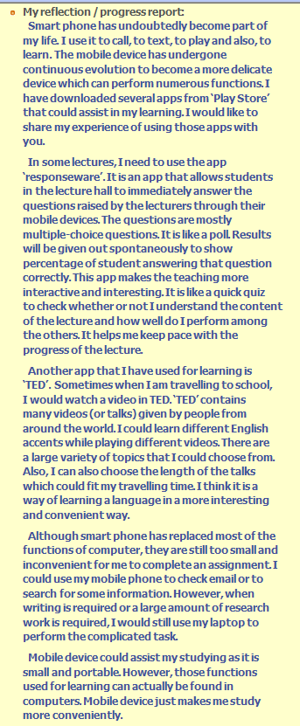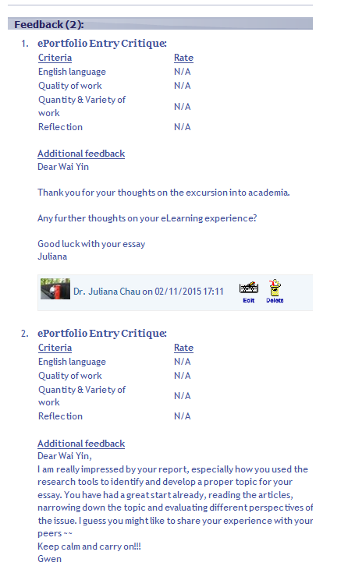

As part of the course requirement, PolyU students on the ELC1014 course submit two academic position argument essays on a topic of their choice, many discipline-related. The first is a 600-word draft, and after receiving teacher feedback, students hand in a polished, final essay on the same topic of 1200 words by drawing on academic sources such as peer-reviewed journal articles. Students then defend their views and engage with those of other groupmates logically and clearly in a mini oral defence. For the BYOD project, the results of the assessments were converted from letter grades to numerical scores in line with university guidelines:
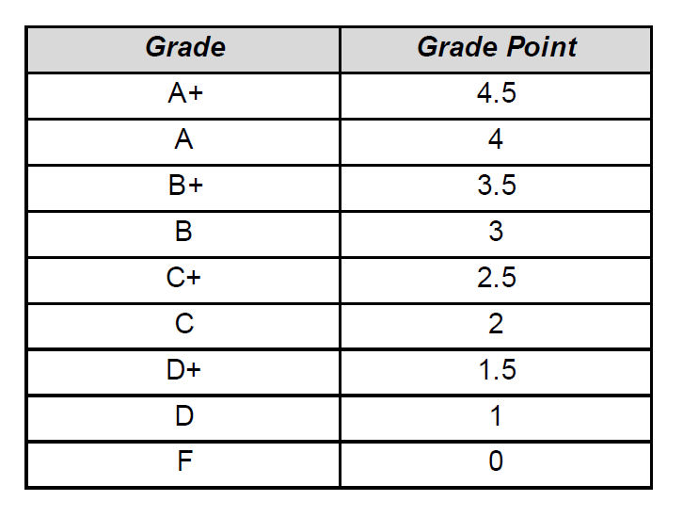

For the HKIEd INT3026 course, 40% of the overall course grade is allocated to examination and 50% to an individual project. The remaining 10% is grade is assigned to class participation where students receive one mark for each task completed in class. To evaluate the impact of BYOD on learning, the participating INT3026 students were instructed to complete an in-class exercise in pencil-and-pen form at two points: pre- and post-BYOD implementation.

- Evaluation

Qualitative and quantitative data from the full implementation stage were mainly used to evaluate the impact of BYOD on learning behaviour and achievement, as well as to highlight the main strengths and constraints of BYOD pedagogies.

- Impact of BYOD on learning behaviour

PolyU
Sixty-four and 35 responses were gathered from the pre- and post- surveys respectively, the main section of which comprised 14 statements on a five-point Likert scale (1 - Strongly Disagree to 5 - Strongly Agree). The paired samples test results and descriptive statistics of the two surveys in percentages are provided below.

 | 2015-16 Sem 1 Paired Samples Test
Item Statistics |  |  |  |  |  | Paired Differences |  |  |  |  | t | df | Sig. (2-tailed)
 |  | Post (n=28) |  | Pre (n=28) |  | Mean | Std. Deviation | Std. Error Mean | 95% Confidence Interval of the Difference
 |  | Mean | Std. Deviation | Mean | Std. Deviation | Mean | Std. Deviation | Std. Error Mean | Lower | Upper
PU1 |  | 4.07 | .813 | 3.75 | 1.005 | .321 | 1.156 | .219 | -.127 | .770 | 1.471 | 27 | .153
PU2 |  | 4.32 | .723 | 3.86 | 1.008 | .464 | 1.232 | .233 | -.013 | .942 | 1.995 | 27 | .056
PU3 |  | 3.93 | .858 | 3.64 | .951 | .286 | 1.117 | .211 | -.148 | .719 | 1.353 | 27 | .187
PU4 |  | 4.21 | .738 | 4.04 | .838 | .179 | 1.188 | .225 | -.282 | .639 | .795 | 27 | .433
PEU1 |  | 4.00 | .816 | 3.96 | 1.071 | .036 | 1.374 | .260 | -.497 | .568 | .138 | 27 | .892
PEU2 |  | 4.18 | .863 | 3.96 | 1.138 | .214 | 1.343 | .254 | -.307 | .735 | .844 | 27 | .406
PEU3 |  | 4.07 | .858 | 3.68 | 1.020 | .393 | 1.286 | .243 | -.106 | .892 | 1.616 | 27 | .118
PEU4 |  | 4.11 | .832 | 3.64 | 1.026 | .464 | 1.347 | .254 | -.058 | .986 | 1.824 | 27 | .079
ABL1 |  | 4.29 | .600 | 4.04 | .999 | .250 | 1.206 | .228 | -.218 | .718 | 1.097 | 27 | .282
ABL2 |  | 3.93 | .813 | 3.82 | .983 | .107 | 1.166 | .220 | -.345 | .559 | .486 | 27 | .631
ABL3 |  | 4.14 | .848 | 4.07 | .900 | .071 | 1.052 | .199 | -.336 | .479 | .359 | 27 | .722
BIBL1 |  | 4.39 | .685 | 4.11 | .994 | .286 | 1.117 | .211 | -.148 | .719 | 1.353 | 27 | .187
BIBL2 |  | 3.89 | 1.031 | 3.86 | 1.008 | .036 | 1.290 | .244 | -.465 | .536 | .146 | 27 | .885
BIBL3 |  | 4.14 | .705 | 4.07 | .979 | .071 | 1.274 | .241 | -.423 | .566 | .297 | 27 | .769
Key: p value below .05 suggests significant statistical difference, which means that there is a 95% possibility that the difference is significant.

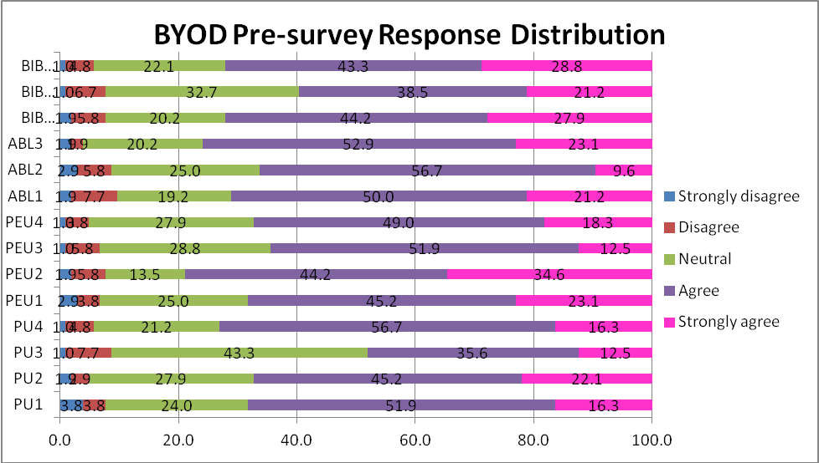

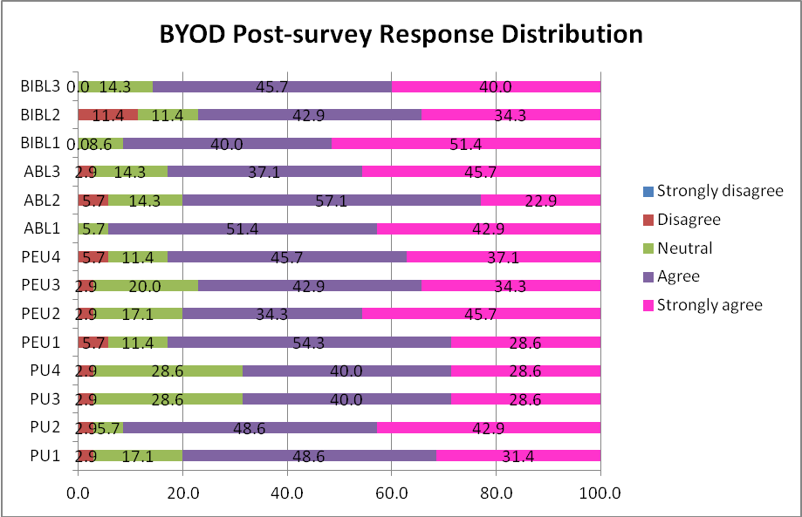

Overall, the means of the pre-survey ranged from 3.48 to 4.02. The items receiving the highest mean included PEU2, BIBL2, and BIBL3, in contrast with the lowest mean recorded for PU3, ABL2, and PEU3. All of the statements garnered an agreement rate (including Agree and Strongly Agree) of over 50%, save for PU3 (48.1%). There was a visible rise in the means in the post-survey – between 3.94 and 4.43. Nearly 70% or above of the responses pointed to either agreement or strong agreement. BIBL1, ABL1, and PU2 registered high agreement rates, while those for BIBL2, ABL2, and PU3 dipped slightly. None of the statements attracted strong disagreement from the respondents. It is evident that the respondents were quite positive towards the use of personal devices for learning and this sentiment was further strengthened with the adoption of BYOD.

In the pre-survey, 78.8% of the students agreed and strongly agreed that their devices were easy to use (PEU2), and 72.1% of them revealed their intention to use their personal devices for learning in the future (BIBL3). However, 8.7% of them (Disagree or Strongly disagree) were sceptical about the beneficial effect of using personal devices on course performance (PU3). Similar doubts were also expressed about BYOD’s potential to increase interest in the course (8.7%, ABL2), or whether accessibility and usefulness of the learning resources and platforms (6.7%, PEU3) might be correlated with BYOD practices.

Post-survey findings suggest respondents’ positive attitude towards BYOD across the 14 items. An overwhelming majority, 94.3%, rated highly the beneficial use of personal devices for in-class and out-of-class activities for learning (ABL1). Similarly, 91.4% concurred that using personal devices had enabled them to complete assignments more quickly (PU2) – an item that registered statistically significant marked increase in agreement ratings in the post-survey. Also notable is the response to PEU4 which inquired respondents if they found it easy to become skillful at using their own devices for learning. While 27.9% of the students opted for ‘neutral’ for this item in the pre-survey, a substantial drop to 11.4% was reported in the post-survey. This, coupled with high agreement (67.3%) and strong agreement (82.9%) ratings, signals growing confidence and competence among students with the use of their own devices for learning over time. The pair t-test results on PEU4 corroborate this significant change.

The PolyU user acceptance survey findings and the paired samples test results show quite clearly students’ favourable opinion about BYOD practice, with an appreciable rise in approval across most items over the implementation period.

HKIEd

2015/16, Semester 1, Paired Samples Test
 |  | Item Statistics |  |  |  |  |  |  | Paired Differences |  |  |  |  |  |  |  |  |  | t | df |  | Sig. (2-tailed)
 |  | Pre |  |  | Post |  |  |  | Mean |  | Std. Deviation |  | Std. Error Mean |  | 95% Confidence Interval of the Difference |  |  |  | t |  |  | Sig. (2-tailed)
 |  | Mean | Std. Deviation |  | Mean |  | Std. Deviation |  |  |  |  |  |  |  | Lower |  | Upper |  | t |  |  | Sig. (2-tailed)
Pair 1 | PrePU1 - PostPU1 | 3.67 |  | .547 |  | 3.77 |  | .504 |  | -.100 |  | .305 |  | .056 |  | -.214 |  | .014 | -1.795 |  | 29 | .083
Pair 2 | PrePU2 - PostPU2 | 3.87 |  | .571 |  | 3.83 |  | .592 |  | .033 |  | .556 |  | .102 |  | -.174 |  | .241 | .328 |  | 29 | .745
Pair 3 | PrePU3 - PostPU3 | 3.57 |  | .626 |  | 3.73 |  | .450 |  | -.167 |  | .461 |  | .084 |  | -.339 |  | .006 | -1.980 |  | 29 | .057
Pair 4 | PrePU4 - PostPU4 | 3.80 |  | .484 |  | 3.83 |  | .379 |  | -.033 |  | .414 |  | .076 |  | -.188 |  | .121 | -.441^{b} |  | 29 | .662
Pair 5 | PrePEU1 - PostPEU1 | 3.93 |  | .521 |  | 4.00 |  | .455 |  | -.067 |  | .450 |  | .082 |  | -.235 |  | .101 | -.812 |  | 29 | .423
Pair 6 | PrePEU2 - PostPEU2 | 4.20 |  | .484 |  | 4.20 |  | .484 |  | 0.000 |  | .455 |  | .083 |  | -.170 |  | .170 | 0.000 |  | 29 | 1.000
Pair 7 | PrePEU3 - PostPEU3 | 3.73 |  | .640 |  | 3.93 |  | .521 |  | -.200 |  | .407 |  | .074 |  | -.352 |  | -.048 | -2.693 |  | 29 | .012*
Pair 8 | PrePEU4 - PostPEU4 | 3.83 |  | .592 |  | 4.07 |  | .521 |  | -.233 |  | .568 |  | .104 |  | -.446 |  | -.021 | -2.249 |  | 29 | .032*
Pair 9 | PreABL1 - PostABL1 | 3.90 |  | .548 |  | 4.10 |  | .481 |  | -.200 |  | .407 |  | .074 |  | -.352 |  | -.048 | -2.693 |  | 29 | .012*
Pair 10 | PreABL2 - PostABL2 | 3.77 |  | .568 |  | 4.17 |  | .379 |  | -.400 |  | .498 |  | .091 |  | -.586 |  | -.214 | -4.397 |  | 29 | .000***
Pair 11 | PreABL3 - PostABL3 | 3.87 |  | .629 |  | 4.13 |  | .434 |  | -.267 |  | .521 |  | .095 |  | -.461 |  | -.072 | -2.804 |  | 29 | .009**
Pair 12 | PreBIBL1 - PostBIBL1 | 3.60 |  | .814 |  | 4.03 |  | .669 |  | -.433 |  | .568 |  | .104 |  | -.646 |  | -.221 | -4.176 |  | 29 | .000***
Pair 13 | PreBIBL2 - PostBIBL2 | 3.73 |  | .785 |  | 4.00 |  | .587 |  | -.267 |  | .450 |  | .082 |  | -.435 |  | -.099 | -3.247 |  | 29 | .003**
Pair 14 | PreBIBL3 - PostBIBL3 | 3.70 |  | .837 |  | 4.13 |  | .681 |  | -.433 |  | .626 |  | .114 |  | -.667 |  | -.200 | -3.791 |  | 29 | .001**
a. *The mean difference is significant at .05 level;
b. **The mean difference is significant at .01 level;
c. *** The mean difference is significant at .000 level;

The pre- and post-surveys garnered 30 responses each. The descriptive statistics in the above table show that the means of the pre- survey responses ranged from 3.57 to 4.20, while those of the post- survey were between 3.73 and 4.20. This seems to suggest that overall, the respondents thought BYOD was advantageous to learning, and there was a slight increase in their acceptance of this approach after the study.

PEU2, PEU1, and ABL1 received the highest average ratings, whereas PU3, BIBL1 and BIBL3 were least endorsed by the respondents in the pre- survey. Similarly, in the post-survey, PEU2, ABL2, BIBL3 and ABL3 were the highly rated ones, compared with PU3, PU1, PU4, PU2 and PU2 which were least rated. It is worth noting that PEU2 was most highly rated (4.20, 4.20), as contrasted with PU3 which remained least agreed (3.57, 3.73) in both surveys. This tends to suggest that the respondents were consistently favourable with the ease of operating their personal devices, but were moderately so about the effectiveness of BYOD in terms of increasing course performance.

While there were slight to moderate rises in the means of PU1, PU4, and PEU1, a decrease of .03 was found with PU2 only, from 3.87 to 3.83. This change might be negligible; however, this finding differs substantially from the PolyU findings, of which PU2 was shown to have undergone a relatively large, though insignificant, increase after the study. It might be argued that students’ perceived usefulness of BYOD for completing assignments quickly might be highly affected by the nature of the assignment and the extent to which digital devices are deployed for its fulfilment.

Statistical significance was identified in the mean differences of PEU3, PEU4, and ABL1 at .05 level, ABL3, BIBL2, and BIBL3 at .01 level, and ABL2 and BIBL1 at .000 level. This finding seems to reveal that the BYOD approach increased students’ confidence in their ability to use personal devices and to access resources and platforms for learning. In view of the evidence, it is highly probable (more than 99.9%) that students’ overall attitude towards and the intention of using personally owned devices for learning purposes can intensify through BYOD pedagogy, regardless of programmes of study or settings.

- Impact of BYOD on learning achievement

PolyU
To evaluate the impact of BYOD on achievement, the assessment results of the experimental and control groups were compared and analysed. Only students from the Radiography Department involved in both groups were selected to ensure consistency in language proficiency and marking standardization. The assessment weighting and criteria for the three assessments used for comparison are outlined below.

ELC1014 – Advanced English for University Studies
 | Overall Assessment Weighting | Assessment Criteria (weighting for each, and code used in the line graphs)
Assessment 1  600-word draft essay | 20% | Content (30%), Con  Organisation (20%), Org  Language (30%), Lan  Referencing (20%), Ref
Assessment 2  1200-word final essay on the same topic | 45% | Content (30%), Con  Organisation (20%), Org  Language (30%), Lan  Referencing (20%), Ref
Assessment 3  mini oral defence | 35% | Content (20%), Con  Delivery (30%), Del  Language (30%), Lan  Pronunciation and fluency (20%) , Pro

The numerical scores used for comparison were converted from the letter grades: 4.5 (A+), 4 (A), 3.5 (B+), 3 (B), 2.5 (C+), 2 (C), 1.5 (D+), 1 (D), 0 (F) (See also table on page 8). The results are displayed in the four line graphs on the next page.

blue line = experimental group (n=17); red line = control group (n=13)
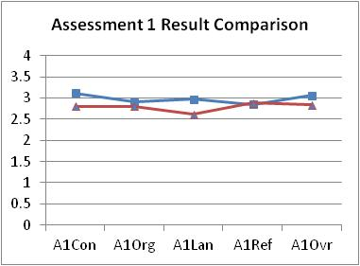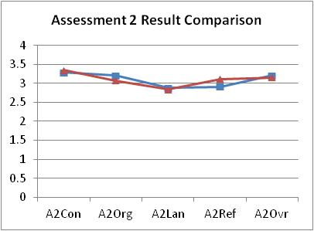

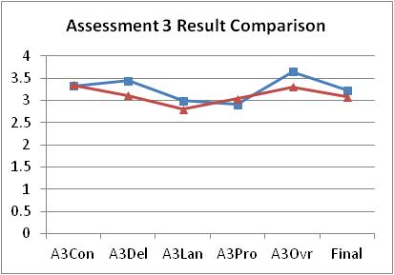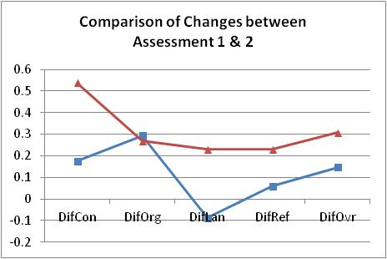

The group means in the above line graphs suggest that the experimental group (blue line, n=17) outperformed the control group (red line, n=13) in nearly all four stated assessment criteria across the three assessments, except in the areas of Referencing in Assessment 1, Content in Assessment 2, and Content and Pronunciation in Assessment 3. However, no statistically significant difference was identified in the grades between the two groups, apart from Language in Assessment 1, suggesting that the experimental group performed significantly better than the control group in language in the draft essay.

To further investigate the impact of BYOD on learning achievement, comparison of the grade differences between assessments was undertaken to ascertain progress made by experimental and control groups. From this, the grade differences from Assessment 1 to Assessment 2 were used for an independent t-test analysis, because Assessment 2 was a revised and polished version of Assessment 1, and the assessment criteria for both were identical. The results demonstrate both groups made improvements between the assessments in almost all the areas and overall performance. None the less, the performance of the experimental group declined slightly in the area of Language. The progress made by the experimental group was also slightly smaller than that of the control group overall except for Organisation. The experimental group posted significantly smaller gains (p<.05) in Content and Language than the control group.

One possible explanation for this can be that the experimental group received higher grades for their draft essay (Assessment 1) – mostly grade B or above – than the control group. The overall grade distribution for the 2015/16 Semester 1 cohort of 897 ELC1014 students shows thus: 0% (A+), 2% (A), 24.7% (B+), 45.6% (B), 19.8% (C+), 4.6% (C), 1.1% (D+), 0.3% (D), and 1.8% (F). In other words, students with B grades would be hard put to progress to a B+ or A grade, given the small percentage of those who achieved this. Even if the students in the experimental group succeeded, the half grade difference would still be less than their counterparts’ in the control group who obtained lower grades for their first assessment.

HKIEd
As noted on page 8, the INT3026 students were instructed to complete an in-class exercise using their personal mobile devices during BYOD implementation and in pencil-and-pen form at two points: pre- and post-BYOD implementation, as part of the course requirement relating to class participation which counts for 10% of the overall course grade. Over the BYOD implementation period, the exercise completion rates were recorded. The topic, format and assessment weighting for six in-class exercises adopted for the study are outlined below.

Exercise | Topic | Format | Assessment Weighting | Implementation Phase
E1 | Network models | Short questions | 1% | Pre-BYOD
E2 | Application layer | Short questions | 1% | Pre-BYOD
E3 | Transport layer | Short questions | 1% | BYOD
E4 | Network layer | Short questions | 1% | BYOD
E5 | Link layer | Short questions | 1% | Post-BYOD
E6 | Network security | Short questions | 1% | Post-BYOD

The following examples show some sample questions used in pre-BYOD, BYOD and post-BYOD phases:

Exercise | Sample question | Implementation Phase
E1 | - Explain why layered networking models are used  - Elaborate on the following terms: Protocol and Encapsulation | Pre-BYOD
E4 | - Given address / prefix of 157.8.148.71/19. What are (i) network address, (ii) broadcast address, (iii) first usable host address, and (iv) last usable host address? | BYOD
E6 | Show the key steps of the process for generating a Web server certificate for security purposes. | Post-BYOD

Completion rate for each exercise can be found at the following table:

Exercise | Completion rate
E1 | 87%
E2 | 93%
E3 | 97%
E4 | 100%
E5 | 93%
E6 | 90%

The results indicate that students achieved the highest completion rates (97% and 100%) during the BYOD implementation (E3 and E4). This can be attributed to the accessibility and efficiency of personal devices. Students could use their own devices to directly search on the Internet for answers to the questions. Alternatively, they could install and use online digital tools (e.g. network address calculator) on their devices to solve problems. Both ways could effectively help students complete their exercises in class.

- Strengths and limitations of BYOD pedagogies

A number of merits and challenges associated with BYOD-mediated learning have emerged from the findings, especially from the students’ self-reflections and focus group responses.

Strengths

- Accessibility and efficiency

Most of the students appreciated the convenience of accessing learning materials and Internet-based resources for learning using their own mobile devices, without having to carry the heavy lecture notes around, or visit the library in person to look up books or other print-based materials. They also found it easy to conduct searches on the internet. Some students reported the smart phone applications were easily available and user-friendly for learning while on the go:

“I will download all the psychology presentation to my smartphone so that I can check them and revise when I'm travelling around.”

Many students said that they could complete the assignments more quickly and efficiently with the use of their own mobile devices: searching for academic articles, editing the reference list, conducting keyword searches, using different search engines such as Google Scholar and the library’s OneSearch. The online spelling and grammar checker had also made proofreading easier, as pointed out by several students. Some used the referencing machine to compile the reference list. Having access to their own of electronic devices thus makes learning ubiquitous, thereby increasing learning efficiency.

“When the deadline is close, I will use my portable device like my laptop. When I was travelling I will type my documents and try to speed up the progress.”

- Engagement and interaction

Use of personal devices can promote student participation and interaction between teachers and students, as the findings suggest. The in-class activities such as paragraph writing practice and giving comments on the Padlet (Appendix 3) have made learning interesting and competitive. More importantly, such activities give voice to students, especially those shy and reserved ones.

“Well, I think it's useful, because…when I was in my secondary school I was so embarrassed that I did not dare to raise my hand and answer in front of the whole class. So it's easier to express my opinion now.”

Student-student interaction is easier and more frequent because of the personal devices. Several students reported that using file sharing applications such as GoogleDrive enabled them to not only share documents for the mini oral defence, but also hold synchronous online discussions and edit the presentation slides together. The availability of the abundant learning resources seems to foster peer support.

As one student observed,

“When I encounter some kind of difficulties in my learning…my friend referred to YouTube videos and said, 'just watch them, you will have understand better.”

- Individualised and independent learning

As students carry their personal devices around, learning becomes more personalised and independent. A student reported using Google to look up unknown words or concepts during lessons, rather than asking the teacher during or after class. Also, the online discussion and peer feedback activities motivated students to pursue some research on their own, as many students confirmed. The readily available online learning resources made it possible for them to explore and consolidate their understanding of a topic without teacher assistance:

“I think there are many online resources that can help us to learn how to write an academic essay, e.g., the academic Phrasebank provides some vocabulary or sentence structures that can help us to become familiar with the style of the writing. And also there may be some online exercises that are not covered in the lesson, but we can access them ourselves through the internet.”

A few students expressed appreciation for the online learning exercises which allowed them to check the answers themselves rather than having to wait for the teacher’s explanation. This facilitates learning according to the student’s own pace and need.

“You can check instantly whether your answer is correct, but for paper work we may need to wait for the tutor to tell you the answer.”

Limitations

- Distraction and computer skills

Distraction and computer skills are the primary concerns about using electronic devices for learning. While some students conceded materials not related to learning, such as pop-up messages and promotional videos, are inevitable on the Internet and could diminish attention, especially during lessons or while working on assignments, others countered by recommending self-discipline to maintain focus. One student also argued that mobile devices could provide welcome diversion to lessen the stress induced by long lectures.

A few students who were not used to or less confident in typing on the computer showed reluctance to use electronic devices in class. Instead, they would write notes on paper or in the print-out copies. Several also expressed feelings of confusion in their attempts to navigate the different interfaces and identify relevant information.

- Internet connectivity and classroom furniture

Internet connectivity and digital inequality are also identified as a source of worry. There may be spots where wifi connections are weak or blocked, causing the computer to slow down. A few students noted the limited number of power sockets in the classroom, which often compelled them either to scramble for seats near such sockets, or to face the prospect of dead batteries during the lesson. In some PolyU classrooms, chairs with writing tops are not sturdy enough to support the weight of a laptop or designed in a way that facilitates in-class activities mediated by mobile devices.

Appendix 1
A BYOD-supported pedagogical framework
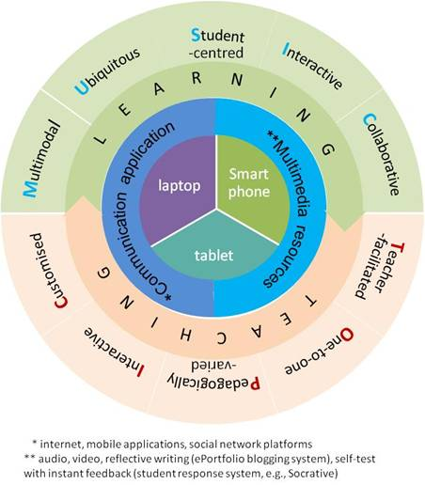

Appendix 2
eLesson Plan with eActivities with reference to BYOD elements – Citation and referencing
Course: ELC1014 Advanced English for University Studies |  | Topic: Citation and Referencing |  |  | Duration: 60 minutes
Learning Objectives (LOs):
By the end of this session students will be able to:
- Use appropriate citation styles in their position argument essay
- Use appropriate citation techniques - quote, paraphrase and summary – to refer to sources
e-activities |  |  | Learning  (M-U-S-I-C) | Teaching  (T-O-P-I-C) |  | Sharing resources | Sharing experience
In-class  Stage 1 | - Read the sample research-driven position argument essay and the four extracts on Padlet (Example A on pp.3-4 of and paragraphs on p. 2 Unit 2) and discuss the questions in a small group:  - What is citing and referencing?  - Why are citing and referencing essential in academic writing?  - When to reference? |  | Collaborative  Student-centred | Teacher-facilitated  Customised  Interactive |  | PDF | Instant response  Peer comment
In-class  Stage 1 | - Watch a video on referencing (Massey University) https://www.youtube.com/watch?v=SOEmM5gmTJM (1:01~2:20, 3:12~4:18) |  | Multimodal | Teacher-facilitated  Pedagogically varied |  | Video
Stage 2 | - Read through the sample essay and discuss  - How does the author cite the sources in the text? – Integral / Non-integral citation  - Why does the author use the sources in those ways?  - How do you know where those sources are from? |  | Collaborative  Student-centred | Teacher-facilitated  Customised  Interactive |  | PDF | Peer comment
Stage 2 | EA4. Work in groups to search the internet to identify resources on the referencing style and share it in terms of the following categories on Google Drive. Co-construct a table of different referencing styles on Padlet.  - Group 1: One author (Edited) Book, Book chapter, journal article, electronic sources, etc.; first/subsequent in-text citation, end-of-text citation  - Group 2: Two authors Journal articles (single author, more than three authors)  - Group 3: Three to five authors  - Group 4: Six and more authors |  | Multimodal  Collaborative  Student-centred | Teacher-facilitated  Pedagogically varied  Interactive |  | Webpage/PDF/Video | Instant response
Stage 3 | EA 5. Work in groups to find examples and rules of how the author uses quote, paraphrasing and summary respectively in the selected article.  - Quote: rules of short and long direct quotes; rules of modifying direct quote; Long direct quote (word count), line space, font, indent  - Paraphrase: effective strategies to paraphrase  - Summarise: effective ways to summarise one or more paragraphs or articles of similar ideas |  | Multimodal  Collaborative  Student-centred | Teacher-facilitated  Pedagogically varied  Interactive |  | Webpage/PDF/Video
Stage 4 | EA6: Individually complete the online exercise (Writing a reference item) http://www.uefap.com/writing/writfram.htm |  | Multimodal  Student-centred  Ubiquitous | One-on-one  Customised |  | Online self-test
Stage 4 | EA7: Individually complete the online exercise (Reporting: Paraphrase, summary and synthesis) http://www.uefap.com/writing/writfram.htm |  | Multimodal  Student-centred  Ubiquitous | One-on-one  Customised |  | Online self-test
Post-class | EA8. Work on your device to complete the exercise:  Writing a reference list http://www.uefap.com/writing/writfram.htm |  | Multimodal  Student-centred  Ubiquitous | One-on-one |  | Online self-test
Additional e-Resources:
- Webpage:
- Purdue APA Format and Style Guide: https://owl.english.purdue.edu/owl/resource/560/01/ ;
- Purdue MLA Format and Style Guide https://owl.english.purdue.edu/owl/resource/747/01/
- Demystifying citing and referencing (Monash University) http://monash.edu/library/skills/resources/tutorials/citing/index.html
- Paraphrasing (Academic English): http://academicenglish.byethost11.com/paraphrasing
- Paraphrasing, summary and synthesis http://www.uefap.com/writing/writfram.htm
- Working with sources (University of Wisconsin)http://writing.wisc.edu/Handbook/QuotingSources.html
- Video:
- Referencing sources in APA style: A basic introduction (Memorial University Libraries) https://www.youtube.com/watch?v=gGtkh_-9OC0
- APA referencing: APA basics (Massey University) https://www.youtube.com/watch?v=SOEmM5gmTJM
- Referencing (UEfAP) http://www.uefap.com/writing/writfram.htm
- Paraphrasing (Academic English) https://www.youtube.com/watch?v=KfKGVbCbdo4
- Quote, paraphrase, summary (10:23) https://www.youtube.com/watch?v=Ral3ldBxQxA
- IT tools to support learner interaction in and out of class:
  - Padlet
  - eLearn platform
  - ePortfolio

Appendix 3
‘Padlet’ in-class Activity

