Personal Learning Environment & Network (PLE&N)

A guide to setting up Google Reader and Google +

The Personal Learning Environment & Network (PLE&N) is developed based on two Google tools –Google Reader, and Google+. This document guides you to set up your PLE&N. Firstly, you must have a Gmail Account (not a Google Account) in order to log in to Google Reader and Google+.

- Share your Gmail address
In order to create a circle so that you may share material with all ISE5605 classmates in Google +, please provide your Gmail address to the Subject Coordinator who will consolidate all the addresses, create the circle and share with the class. If you do not have a Gmail account yet, please create one. Again, you MUST create a Gmail address i.e. XXX@gmail.com

- Setup Google Reader and import RSS feeds
You need to set up your Google Reader by going to www.google.com then select Reader. When you unzip the downloaded file containing this guideline, you also have a copy of the Knowledge_Communities_OPML.xml file. Now logon to your Google account and launch Google Reader
Now, press the ‘Reader Settings’ button.
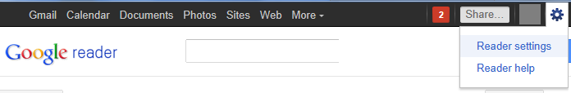
Go to “Import/Export” tab, select the above OPML (.xml) file to import your pre-selected subscriptions. Click ‘upload’ and wait. The subscription process is now completed.
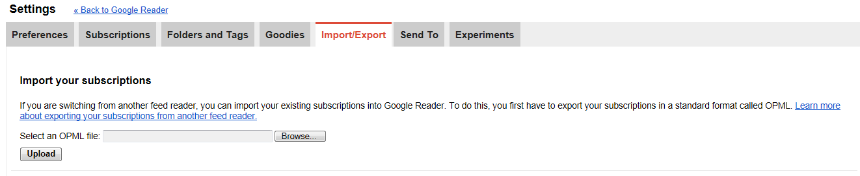

You can now view your RSS feeds in Reader.

- Add an ISE5605 Circle in Google+
You need to add an “ISE5605 Knowledge Communities’ circle before you can start to read, contribute and share with other members. You will receive an invitation email from your Subject Coordinator with names in the Circle.
(If you have not yet registered with Google+, click ‘Join Google+’. Otherwise, please click ‘View circle’.
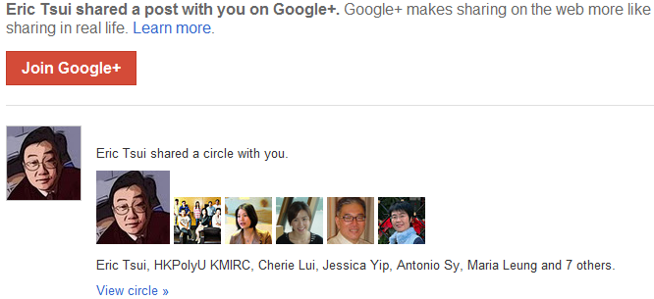

And then ‘Add circle’.
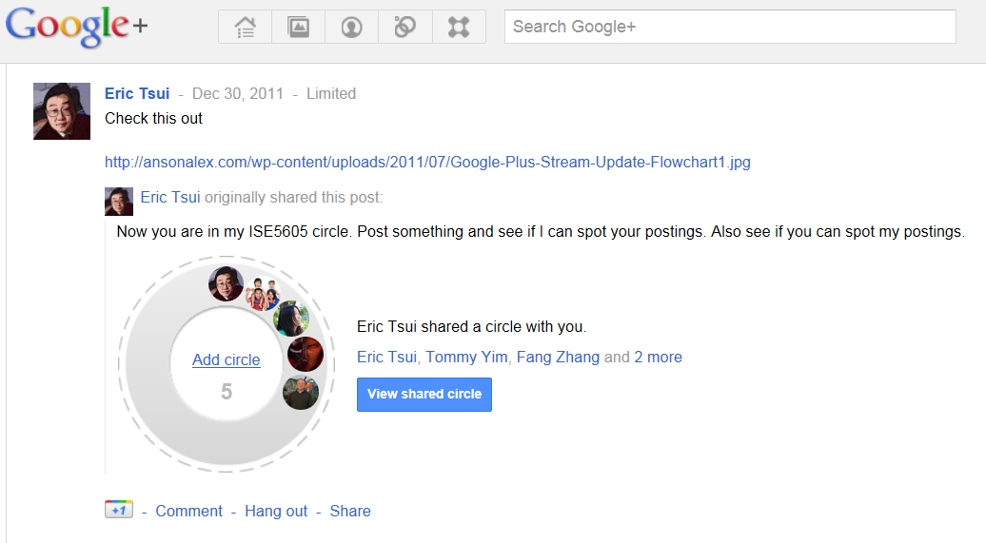
Name the circle as “ISE5605 Knowledge Communities’, and click ‘Create ISE5605 Knowledge Communities Circle’.
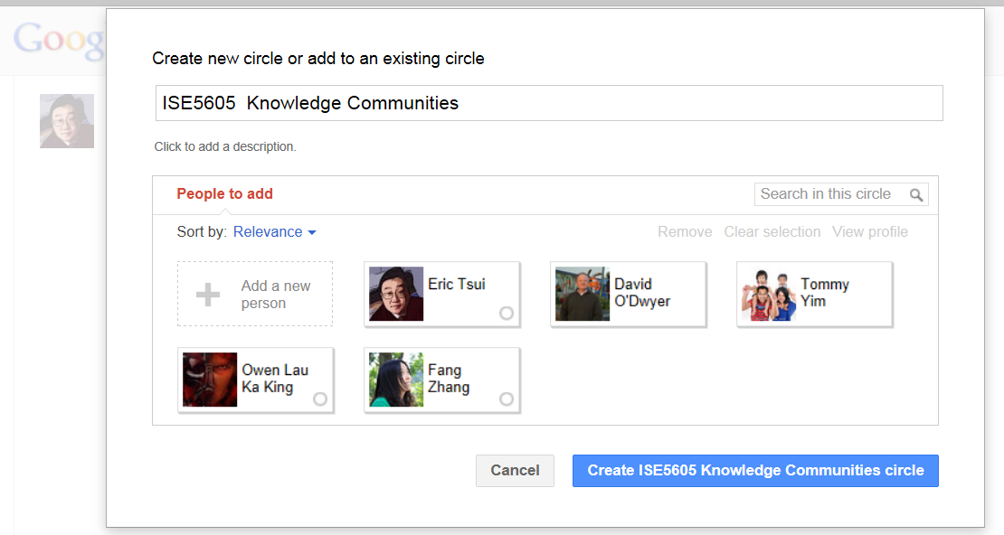
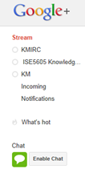
This circle now appears in your circle list. If you would like to check the discussion in the Google + Circle, go to the homepage of Google+. and then click ‘ISE5605 Knowledge Communities’ on the left hand bar under ‘Stream’. Always go directly to the Circle to read the postings instead of Stream as, depending on your reading preference, some postings may not appear in Stream and vice versa.

- How to contribute and share
You may contribute in four ways. Firstly, you may contribute by creating a new posting. Secondly, you can Like or Comment on an existing post. Thirdly, you can re-share a post from another circle into the current circle. Finally, you may share an article from your Google Reader with members in a Circle.

- Create a new posting
In Google+, You will find a box, like the one shown below, in your Google+. You may create a new post by inserting Photo/ Video/ Link/ Location/ Text Message in the provided box.
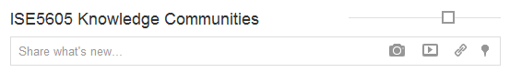

- Like or Comment on an existing posting
In Google+, if you like a post, please click ‘+1’. You may also click on the ‘comment’ button to post a comment.
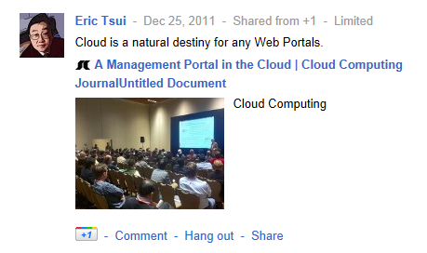

- Re-share a posting from another circle
When you’ve found a posting from another circle that you’d like to share in ISE5605 Knowledge Communities circle, click ‘Share’ and select ISE5605 Knowledge Communities circle.
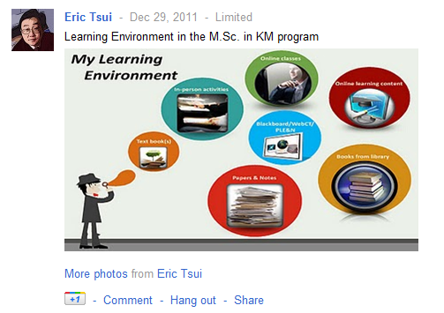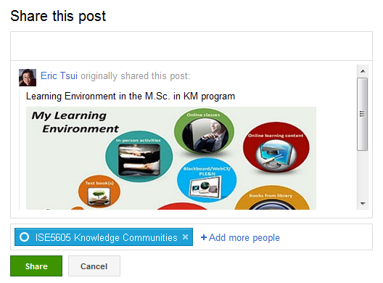

- Share from Google Reader
In Google Reader, when you encounter a posting which you’d like to share with other ISE 5605 classmates, you may click the ‘share’ button. You need to select ‘ISE5605 Knowledge Communities’, and then click ‘share’ again.
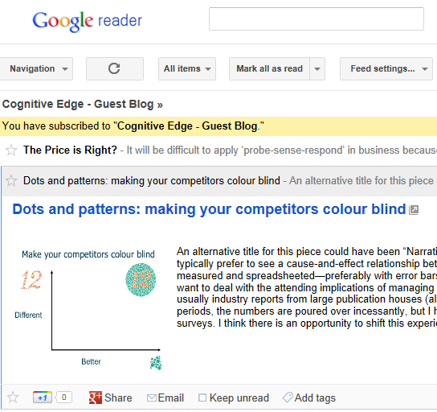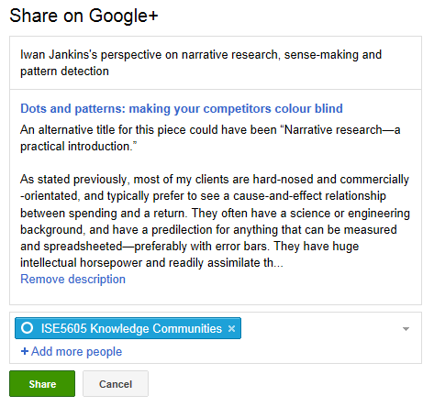
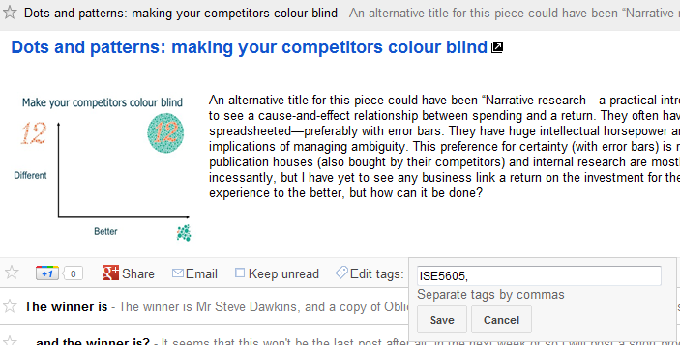
Sometimes, you may also like to post publicly for everyone in your Google+ circles by clicking ‘+1’ box. Or, you can click the ‘email’ button to send the posting to others’ email boxes.

- Tag a posting in Google Reader and Google+
In Google Reader, you may tag your posting by clicking ‘Edit tags’. Then, please type ‘ISE5605’ (no space between ‘ISE’ & ‘5605’) and any other tags of your choices. Then, please press ‘Save’.
In Google+, you need to add a hashtag (i.e. #) before a tag. For example, to tag a comment or a new posting, you should type #ISE5605 (not ISE5605) in the provided text boxes. You may also insert other tags by adding hashtags before them.
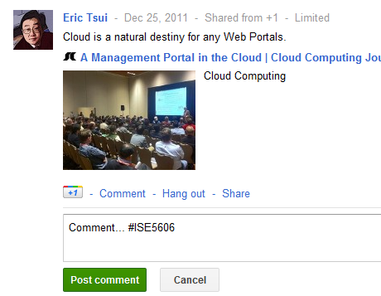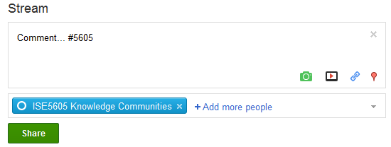

Congratulations!! You have set up your The Personal Learning Environment & Network (PLE&N) for this subject/topic. Thank you for your efforts. You are welcome to provide feedback and/or suggestions to this guideline and the PLE&N.

Project Leader: Project Assistant:
Prof. Eric Tsui Jessica Yip
Phone: +852 2766 6609 Phone: + 852 3400 3187
Email: Eric.Tsui@polyu.edu.hk Email: jessica.yip@connect.polyu.hk
 | 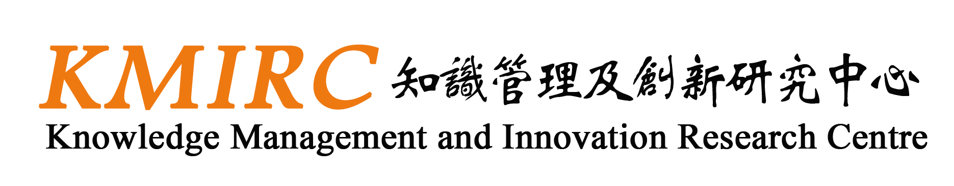
03/1/2012

2Since this circle name is entirely for your own use, you may like to choose a shorter name e.g. ISE5605 for the sake of simplicity

