Catalog
Chapter 1 Introduction 1
I. Overview 1
II. Software Operating Environment 1
III. How To Setup 1
Chapter 2 Overview of Microwave Imaging 3
I. Understanding of Microwave Imaging Software Interface 3
II. Console Window 4
Chapter 3 Simulation Process 6
I. Setting Initial Parameters 6
II. Initialize Scatter Attribute 7

Introduction

Overview
Microwave imaging presents a new direction in the application of Electromagnetics. It has significant advantages over its traditional counterparts. For example, compared with the X-ray imaging technique, its salient advantage is the ability to distinguish small variances in the permittivity of the scatter, resulting in an early detection and timely medical intervention of cancers to long term survival and life quality for patients. Compared with the magnetic resonance imaging technique, its predominant characteristic is economically cheap in system construction. Moreover, microwave radiations provide a rather safe exploration of tissues, because they are not ionizing. Therefore, microwave imaging system has very good potential in engineering applications. In this regard, it is essential to have our undergraduate students of electrical engineering to understand and grasp this knowledge in the Applied Electromagnetics course. It can also raise students’ interest to learn this subject.

Software Operating Environment
- This software can operate over the Windows XP\Windows Server 2003\Vista\Windows 7 operating system.

How To Setup
Open the folder and double click the 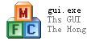 to start the software.
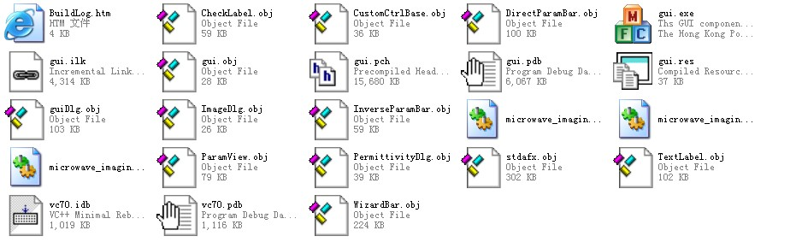
Figure 1-1 The related files

Overview of Microwave Imaging

Understanding of Microwave Imaging Software Interface
You will see the software interface as shown in Figure 2-1 after the software is started, which mainly includes two parts, such as the display window and the main interface.
Main
Interface
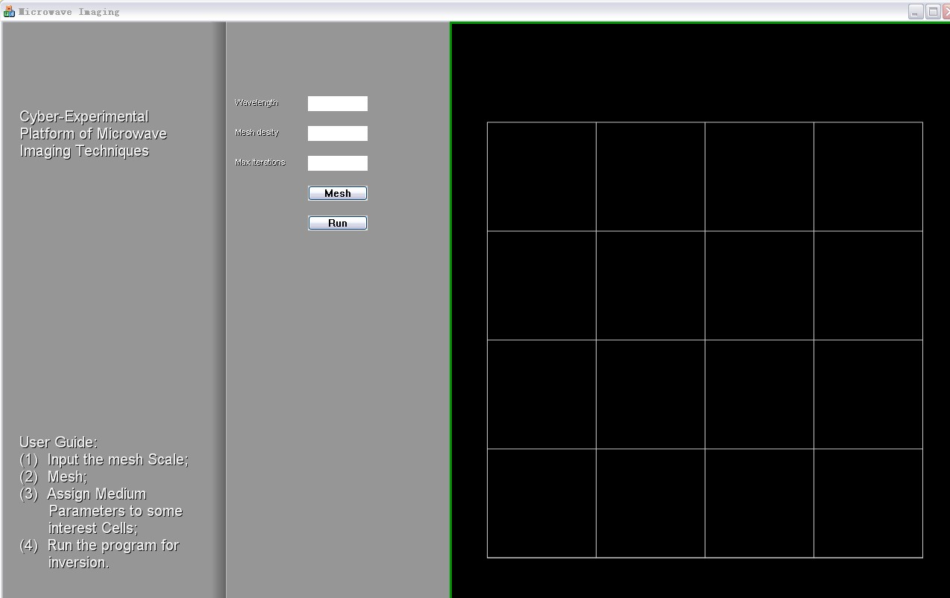
display Window
1
2
3
6
4
5
Figure 2-1 Microwave Imaging Software Main Interface

Display Window
The display window shows the solution domain, the mesh, as well as the intermediate imaging results, which is updated by predefined steps (10 defaulted).

Main Interface
The main interface is composed of three text boxes to initialize the imaging, two buttons and User Guide, which are 1. Wavelength, 2. Mesh desity, 3. Max iterations, 4. Mesh, 5. Run, 6. User Guild in turn.

Console Window
You can also see the console window as shown in Figure 2-2 after the software is enabled, which shows the real results displayed in the display window.
The final result in the console window as shown in Figure 2-3 is composed of three parts, such as the number of iterations, the best value and the final imaging results in turn.
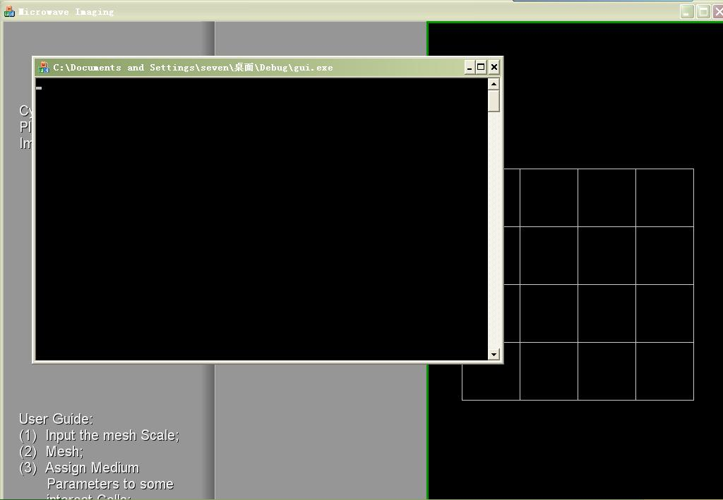
Figure 2-2 Console Window
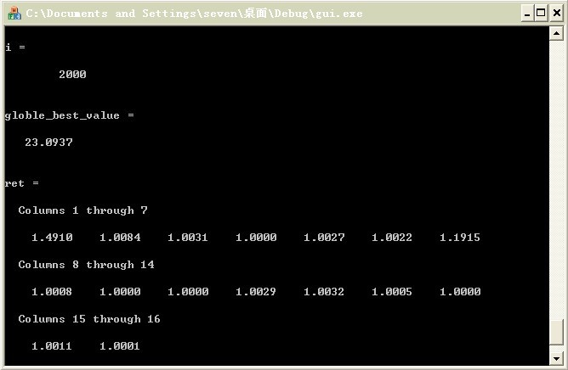
Figure 2-3 The final imaging results in the Console Window

Simulation Process

Setting Initial Parameters
It is necessary to set the initial parameters correctly. Otherwise, it may not work or work unfunctionally.
Setting Method: Input the initial parameters as shown in Figure 3-1: Wavelength > Mesh desity > Max iterations.
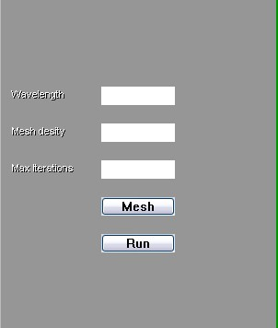
Figure 3-1 initial parameter textbox
- Wavelength: denotes the wavelength(m) of a single frequency TM incident field.
- Mesh density: the solution domain of a square is partitioned into N×N subdomains respectively. E.g. N=4, there will be 16 subdomains.
- Max iterations: the number of maximum iterations for the optimal algorithm to run.

Note: here, the size of the Mesh density could not be set too large (N>5) because it will result in a huge amount of computational burdens on computational resources. In general, you can use the default parameters.

Initialize Scatter Attribute
You can activate the meshing process by clicking the button in the main interface and then double clicking a cell to assign atribute (the permittivity) to the cell in question (as shown in Figure 3-2).
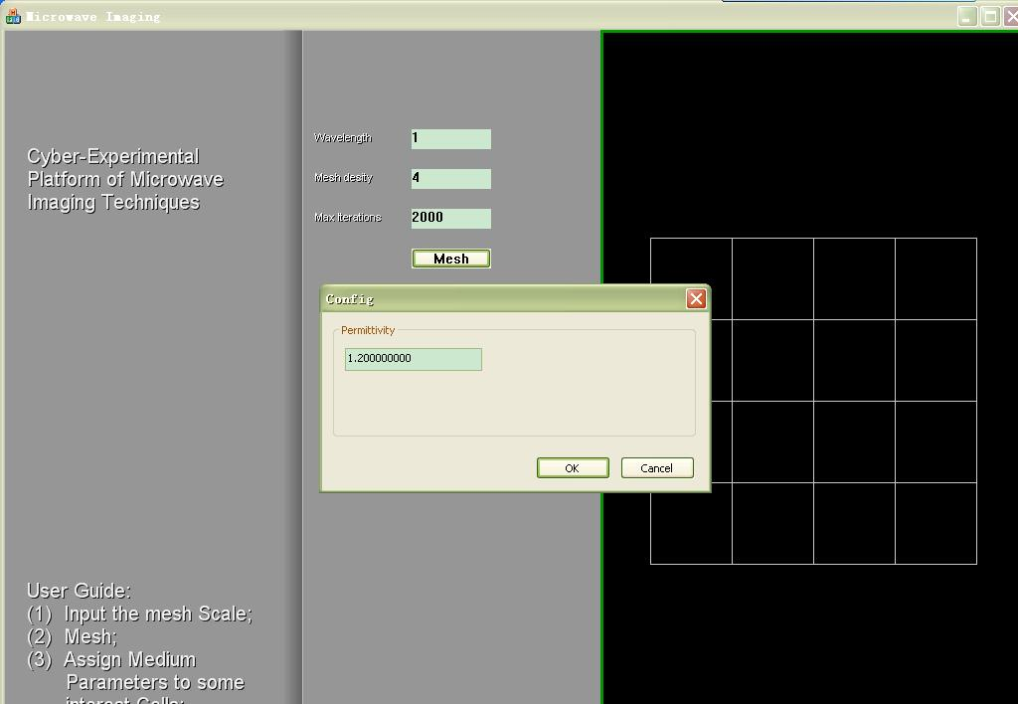
Figure 3-2 Initial mesh
After the preceding procedures, you could start the imaging process by clicking the button , and the intermediate imaging results will be displayed on the window.
After the whole process of simulation is completed, you can see the intermediate result in the display window. A few minutes later, you can see the comparison of initial Scatter Attribute and reconstruction as shown in Figure 3-3. You can also check the permittivity by double clicking the cell as shown in Figure 3-4.

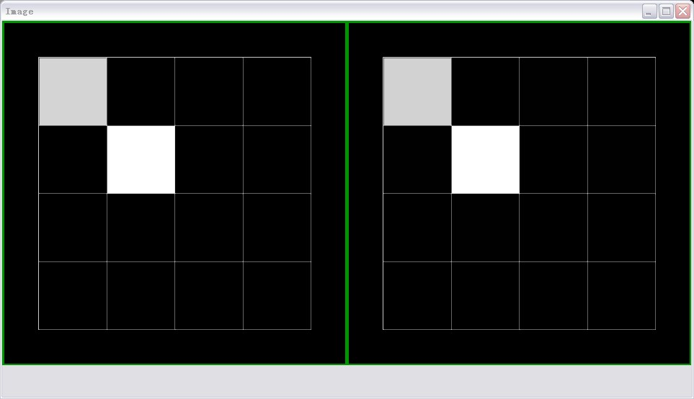
Figure 3-3 Comparison of scatter attributes
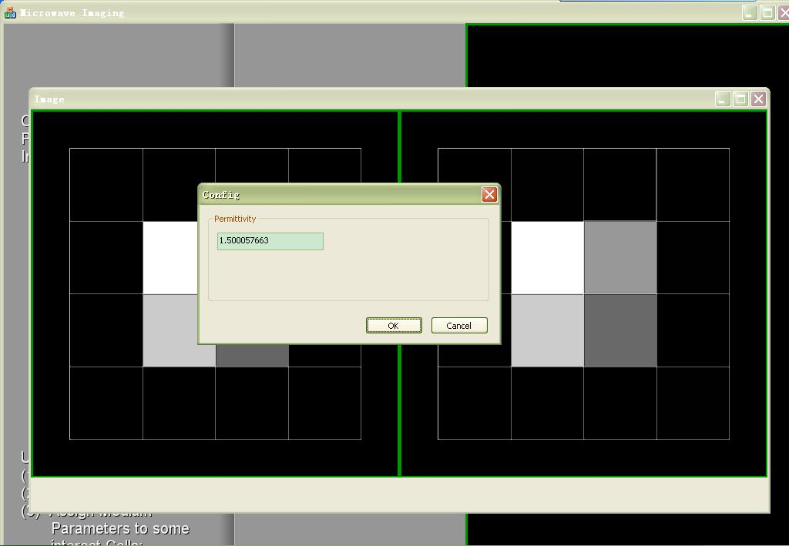
Figure 3-4 Permittivity checking

