For professionals (i.e. FH students)

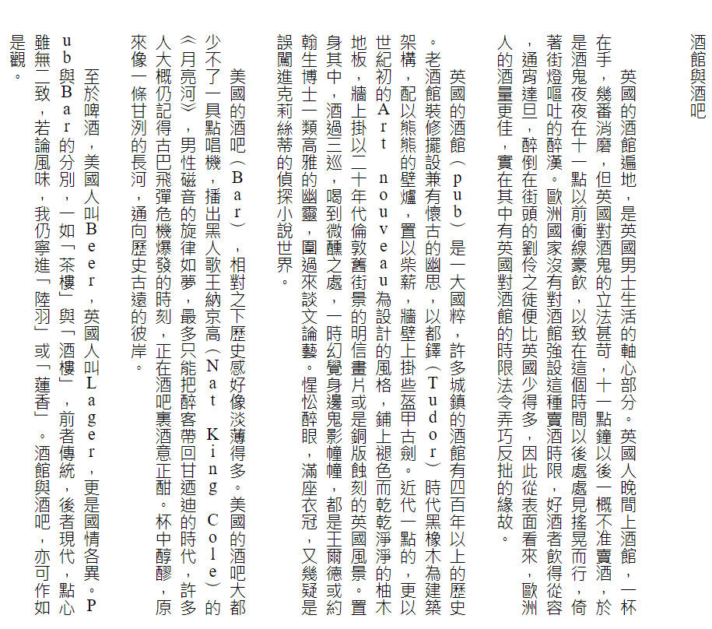

https://www.haodoo.net/?M=u&P=B15U7:21&L=book

